Nuventive Improvement Platform

Welcome to the Nuventive Improvement Platform Help Guide. This Help Guide will walk you through the structure and navigation of the Nuventive Improvement Platform screens.
  - Help Guide

Improvement Platform Help Guide
Contents
Welcome 2
Basic Navigation 2
Top Navigation Bar & Icons 3
General Information Form/Custom Form 8
More Custom Forms 10
Program Goals/Objectives/Outcomes 12
Mapping of Goals/Objectives/Outcomes 16
Entering Goal Updates/Results 17
Program Learning Assessment 23
Entering Program Assessment Results and Analysis 30
Course Assessment 40
Entering Course Assessment Results and Analysis 50
Mapping 57
Reports 64
Document Library/Repository 65

Welcome

Welcome to the Nuventive Improvement Platform Help Guide. The purpose of this help guide is to walk you through the navigation of the Nuventive Improvement Platform. Before we begin, it is important to note that the configuration of your Nuventive Improvement Platform screens may not mirror exactly the example we provide in this help guide. Each instance of the platform is customized to meet the unique needs of each institution. This includes the menu, field labels, list values, and custom fields. If at any time you have questions about the configuration of your specific instance of the platform, please contact your Nuventive Professional Services Consultant.

Basic Navigation
Accessing the Nuventive Improvement Platform is simple and straight forward. It is supported on Apple Mac iOS as well as Microsoft Windows. The Platform is most compatible with Google Chrome or Firefox Web browsers; our recommendation is to avoid the use of Internet Explorer for accessing and using this software. Once you have logged into the Nuventive Improvement Platform, you should first see a screen similar to the one below.
Example: Improvement Analytics Dashboard
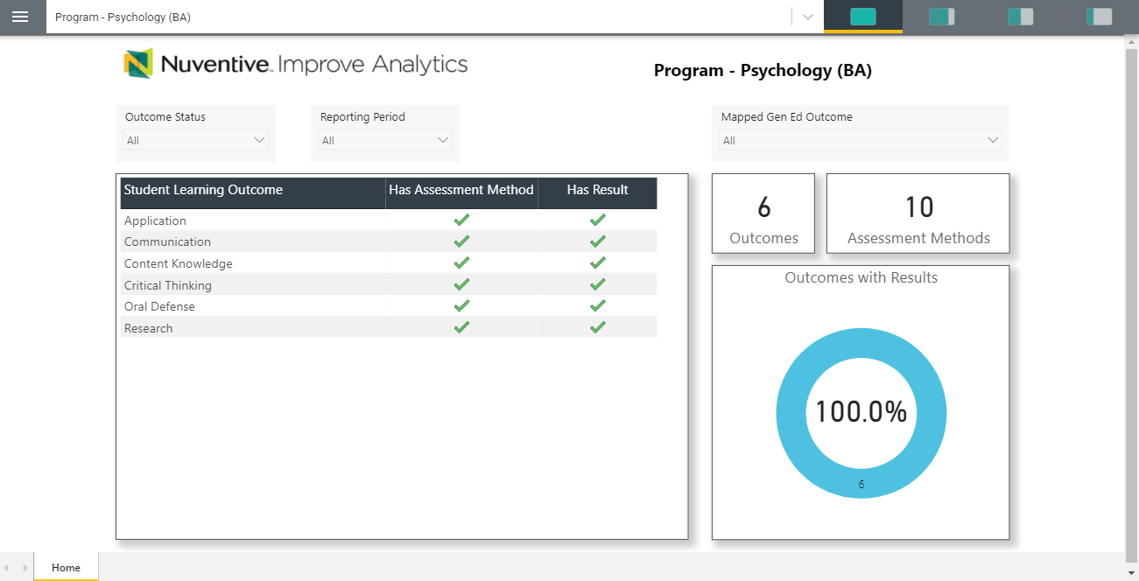

Top Navigation Bar & Icons

At the top of each screen you will find two sets of icons (to the left and right) and a drop-down in the center. This is primary navigation bar through-out the platform.

Hamburger Menu
Unit Drop-down
Data View/Split Screen/
Documents & Reports
Instructions | 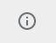
Ellipsis
Plus (+) Sign
Hide
Unhide

  - The Unit Drop-down
The center unit drop-down is where you will locate your unit/units in the platform. By clicking the down arrow/caret to the right in the drop - down you will be able to locate the unit/units that are available to you. If this is your first time logging in, and you do not see your unit, please contact your institution’s assessment contact. If there are numerous units listed in the drop – down, you may type in the drop - down box to quickly locate a unit.

  - The Main Menu (Hamburger Menu)
HOME/DASHBOARD  GENERAL INFORMATION  ANNUAL REVIEW  PROGRAM GOALS  PROGRAM LEARNING ASSESSMENT  COURSE ASSESSMENT  MAPPING  REPORTS  DOCUMENT LIBRARY/REPOSITORY | Now that you have found your unit, click the hamburger icon on the left to reveal your platform menu. NOTE: Your main menu will differ from this example, as your institution has designed your menu specifically for your institution’s needs and processes. Most menus, however, will include the following headings: Home or Dashboard, General Information, one or more of the Assessment processes, Reviews, Mapping, Reports, and Document Library/Repository. Feel free to explore your menu by clicking on any of the menu headings.

  - Split Screen/Documents and Reports
To the far right of the navigation bar you will find a set of icons referred to as Split Screen/Documents & Reports. Under the icons, a space is provided for various documents/reports to be viewed. This area can house the following type of documents: Word, PDF, Excel, Video, HTML, Power BI Reports, etc. The purpose of this area is to provide you with information that you (or your institution) deem necessary to complete your tasks in the Nuventive Improvement Platform. Each of the icons represent the amount of space to be taken up on the screen (split-screen view) when clicking on and opening an item in the list. This expansion allows you to view the information provided in this area from an intelligible viewpoint.

The following are examples of the expanded Split Screen/Documents & Reports areas.
View 1.
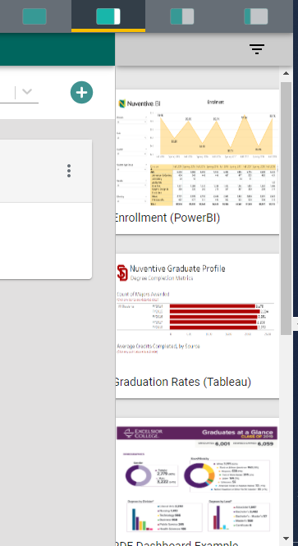

View 2.
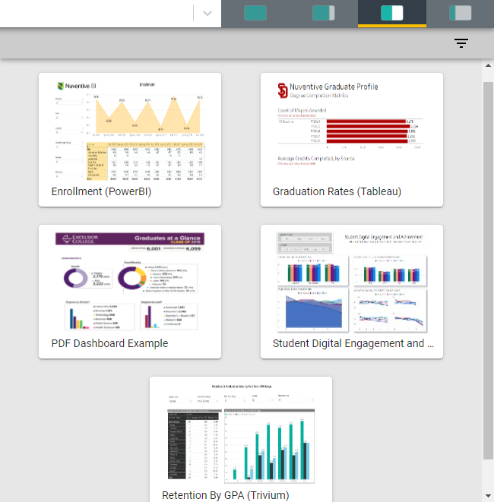

View 3.
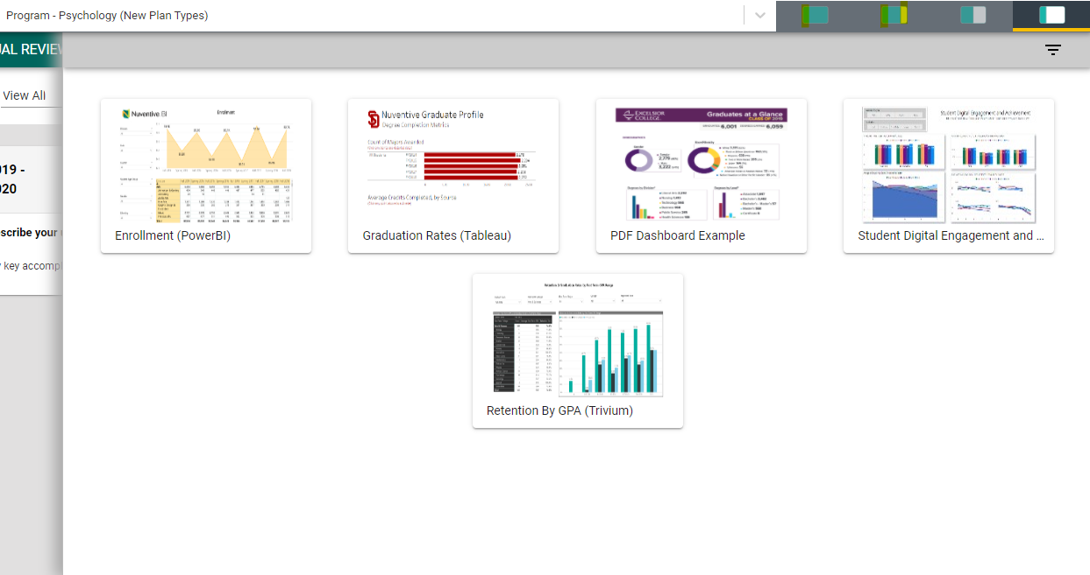

NOTE: The area will also expand to the first level of expansion by clicking on a document/report in the list. You can expand further, or minimize the view of the document/report, by again clicking on one of the icons.
  - Other Important Navigation
Throughout the Platform, wherever you see this icon, instructions may have been provided for that specific field, item, or area. Clicking on the icon will reveal any instructions that have been made available.

Throughout the Platform, wherever you see this icon, options will be presented by clicking on the ellipsis. Typical options include: Open, View/Print, Copy, and/or Delete.
Throughout the Platform, wherever you see this icon is where you will click to Add a NEW Goal, Outcome, Objective, or other element to that screen.
In several places throughout the Platform, you will find these icons. Clicking on the icon allows you to choose between leaving the highlighted information available as you enter information, or you can click the Hide icon to hide the information. Unhide allows you to uncover the highlighted information.

General Information Form/Custom Form

GENERAL INFORMATION

The General Information/Custom Form is a highly customizable form that can be set up for a variety of functions/processes. On initial setup, your institution may have chosen to provide a General Information form where you will enter information about the institution, college, department, program, and/or unit, such as the Mission Statement, Contact Information, and dates of future accreditation reviews. The General Information form will appear as the second page of one of the Standard Reports.
To enter information on the General Information form, begin by clicking on the green circle with the plus (+) sign icon on the card.

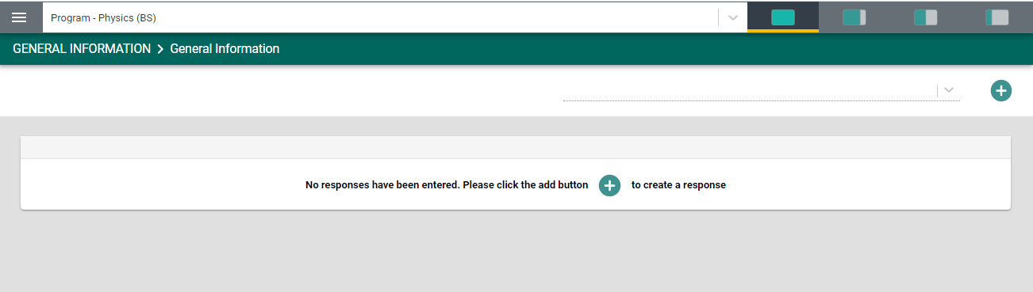
Once clicked, the form will open to the following view.
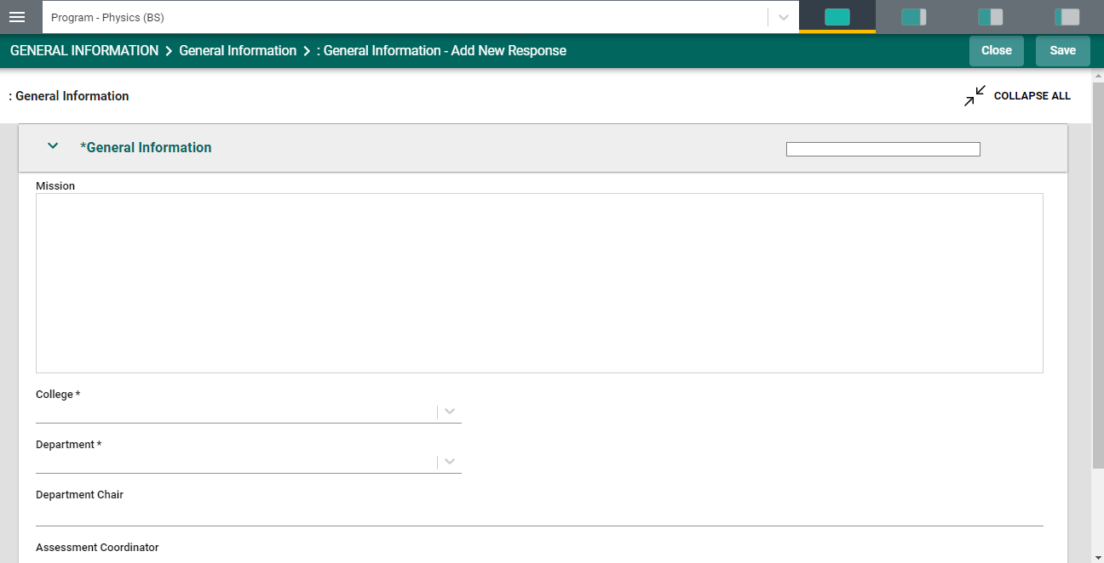
Complete the form fields/text boxes, as designated, by clicking in the text box or selecting from the drop - down. NOTE: Where you see an Asterisk (*) next to the name of a field, that field is required, and you will not be able to save the form until information has been entered into that field. Next, SAVE, by clicking on the SAVE button at the top of the screen.
Once you have saved the form, you should see the completed information as depicted below.

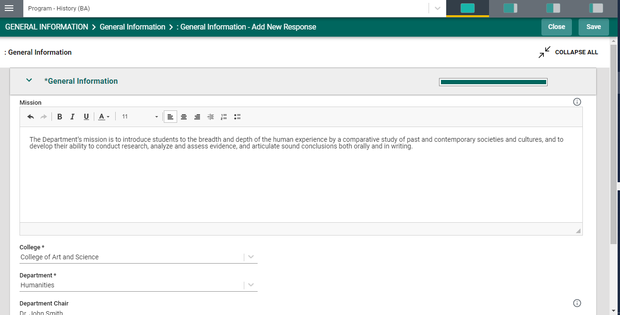
Once you are satisfied with the information you have entered, and have saved the form, click the Close button at the top of the screen. You will now see the following view of the form.
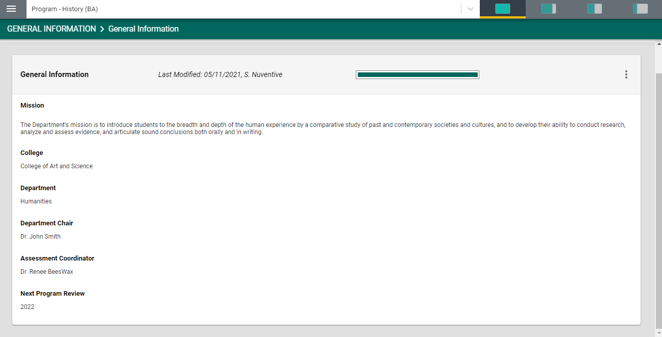
If at any time you need to edit, copy, view/print, view the audit log, or delete the form, click on the ellipses on the top right of the General Information form.

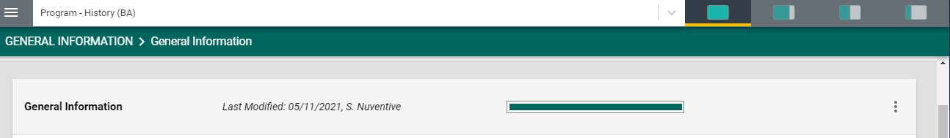

More Custom Forms

If a Custom Form has been set up for other processes, such as Assessment Review, Program Review, and/or Annual Review, etc., you may see these headings in your main menu. For this example, we are using Annual Review.
ANNUAL REVIEW

While the overall function of entering information on this custom form will be the same as the General Information form, there are some differences such as selecting from multiple date cycles.

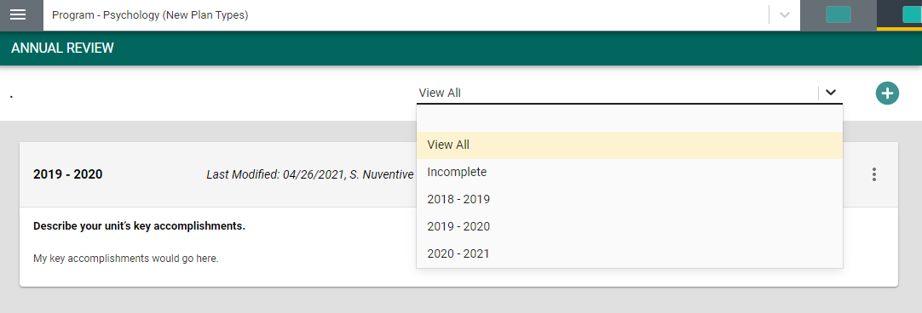

If you will be adding information to a specific date cycle of the review form, select the cycle from the drop-down. Then, proceed with completing that form. Once you have completed the fields within the form, remember to SAVE your work and Close the form.
Once closed, each cycle will be exhibited as indicated in the graphic below. Notice that in the example the drop-down is set to View All. This means that you will see all cycles that have been configured for this custom form. You may choose a specific cycle (2020 – 2021) from the drop-down, in which case you will only see that cycle of information presented.
Another feature of the custom forms is the progress indicator bar. Notice in the graphic below that there are two bars: one yellow and one green. These bars provide, at-a-glance, which forms have been completed (the green filled bar) and which of the forms have not been completed (the yellow bar).

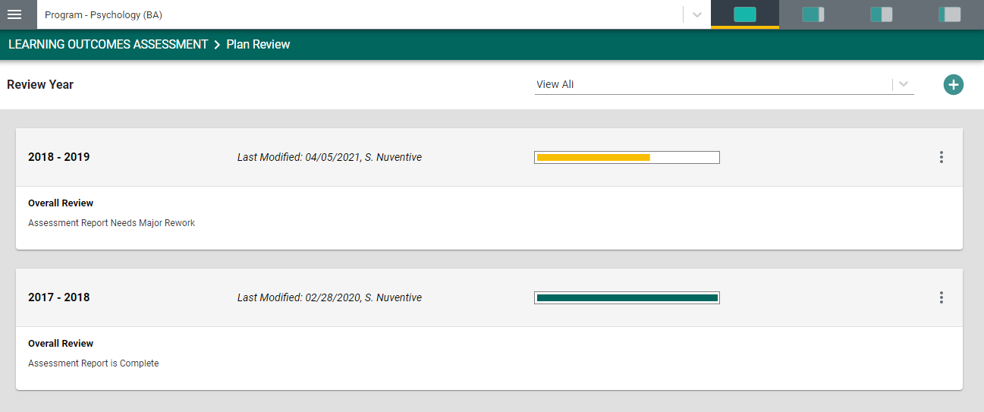

Program Goals/Objectives/Outcomes

For this example, we are using the term Goal. Your screens may reflect a different term (Objective or Outcome), but the functionality will remain the same. Also note, that the page/screen where the goal/objective/outcome is located may be referred to as a card.
To add a new goal, click on the green circle with plus (+) sign on the top right.

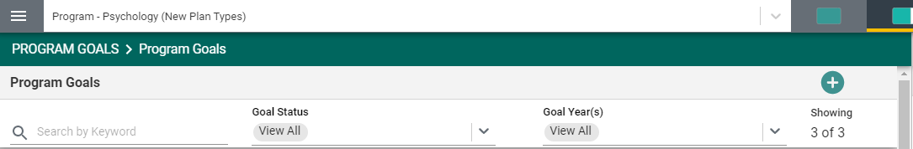

This will open the following card.

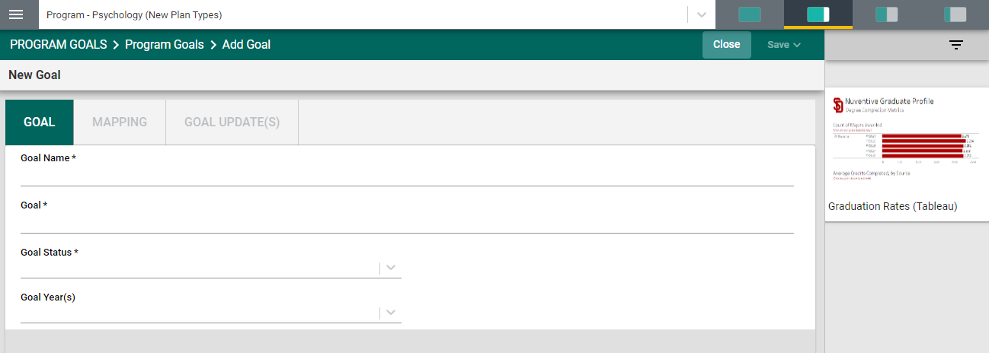

Next, type in each field provided to enter the Goal Name and Goal. Next, click on the arrow/caret to open the Goal Status drop - down. Select Active or Archived from the drop – down. Then, click on the down arrow/caret to reveal the Goal Year(s) drop – down selections. Select from the drop-down. This is a multi-select field, so you can select multiple years.
Note: Where you see an Asterisk (*) next to the name of a field, that field is required, and you will not be able to Save the card until information has been entered into that field.
Once you have completed entering the goal information, SAVE your work by clicking on the Arrow/Caret next to the SAVE button at the top of the screen. Notice that when you click the Arrow/Caret on the SAVE button you are provided with the options to Save & Add New or Save & Close this goal. If you have additional goals to add, click the Save & Add New. If you have finished adding goals, click the Save & Close.

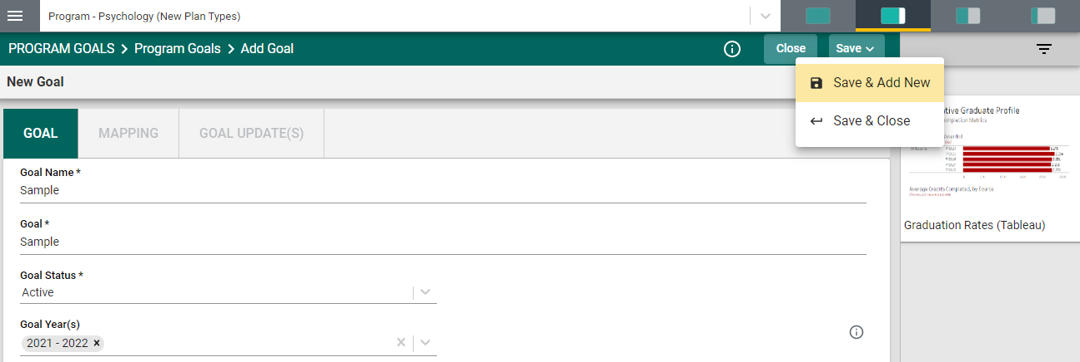

Once you have finished adding goals, click the Save & Close. The following screen will appear showing the goals that you have added.

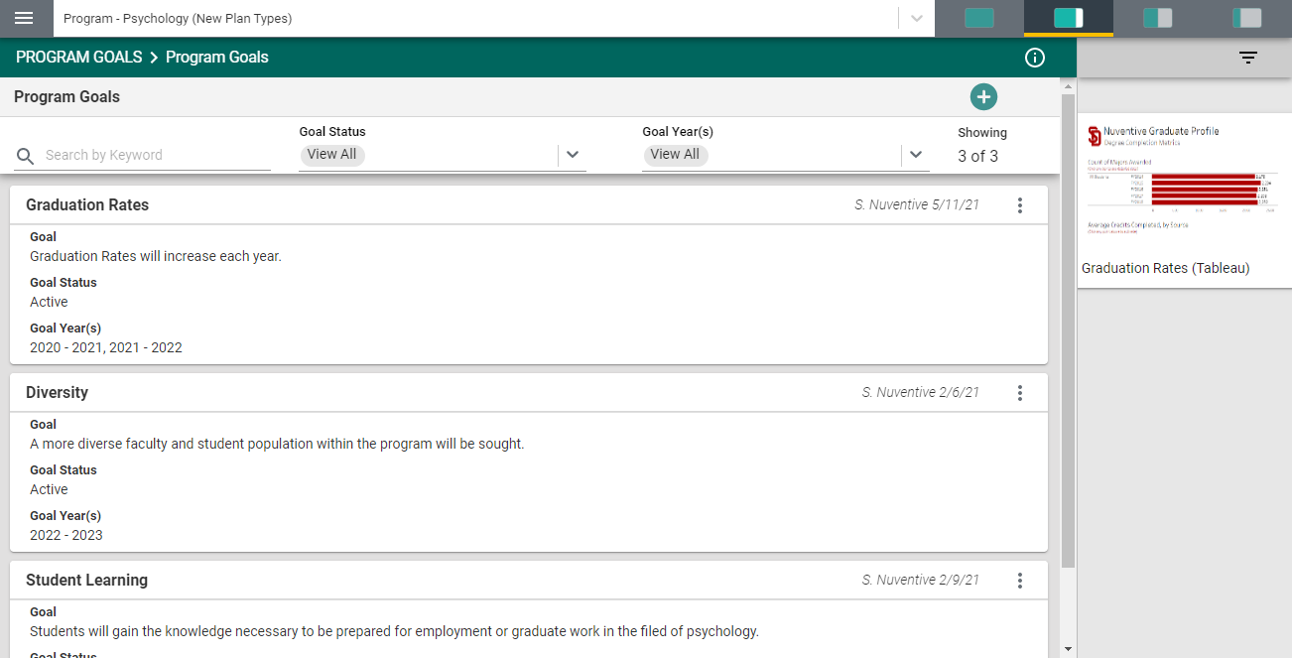

Notice that in the top bar, above the goal cards, that you can locate a specific goal by Search by Keyword, by showing only the goals that are Active or Archived, showing the goals by Goal Year(s), or by showing all goals by selecting View All in each heading.
NOTE: As you add goals, the number of goals that have been entered is reflected at the top, right, of the goals/cards. In this example you see “Showing” 3 of 3.

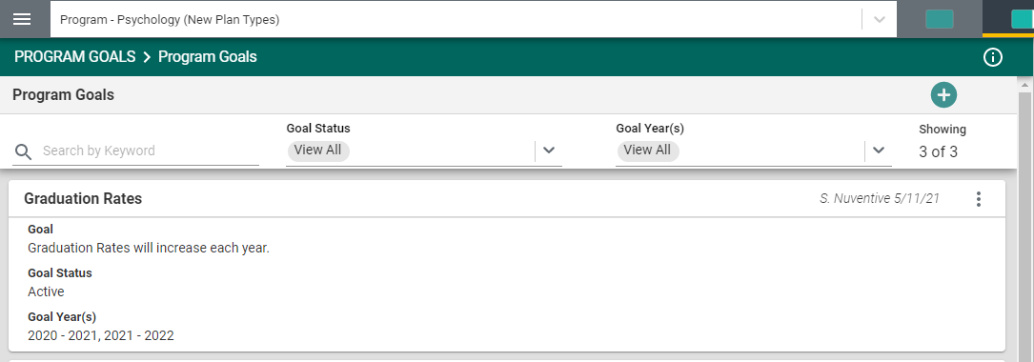
To edit a current goal, locate the ellipsis to the far right of the card.
Once you click on the ellipsis you will be provided with the options to Open, View/Print, or Delete the goal. Keep in mind that if there have been updates/results entered for any goal/objective/outcome, deleting any goal/objective/outcome will also remove any updates/results that have been entered for that specific goal/objective/outcome.

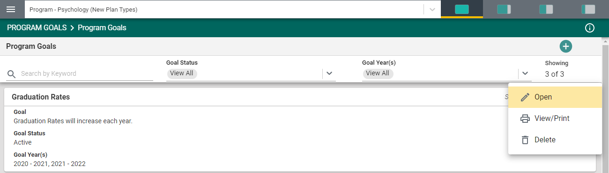

Clicking on Open will open-up the current card for review and/or editing. View/Print will allow you to view the entire card in print-view mode and you will be able to Save the card to your computer for printing. Delete will remove the entire card permanently and any results that have been entered for that goal.

NOTE: When working within the goals/cards, you may move between goals/cards by using the navigation < 1/3 > as seen below. This number of goals/cards will change as you add or remove goals/cards. Remember to SAVE any edits that you have made before moving to another goal/card.

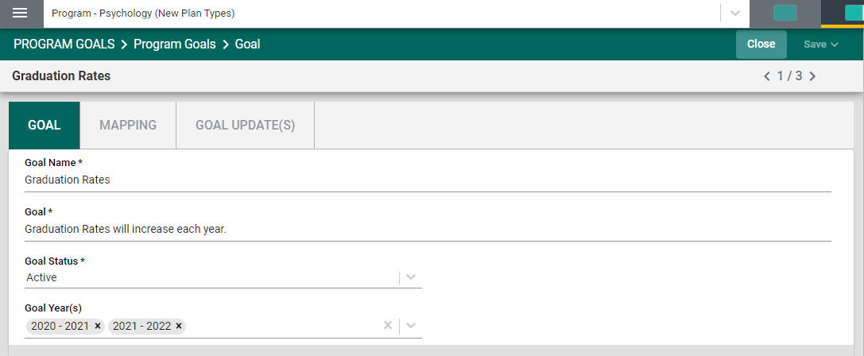

Mapping of Goals/Objectives/Outcomes

Clicking on the MAPPING tab will navigate to the Mapping page/screen where the unit can map their Unit Goals with other institutional outcomes. The Mapping tool is a diagnostic tool and the mapped elements can be visible on various Standard/Analytic Reports. To begin, select the institutional outcome from the drop-down (under the green highlighted tab – MAPPING) on the left. To map a goal, click in the box/space to the right of the institutional goal. The indicator (D/I – for this example) denotes that the goal has been mapped to the corresponding institutional outcome.
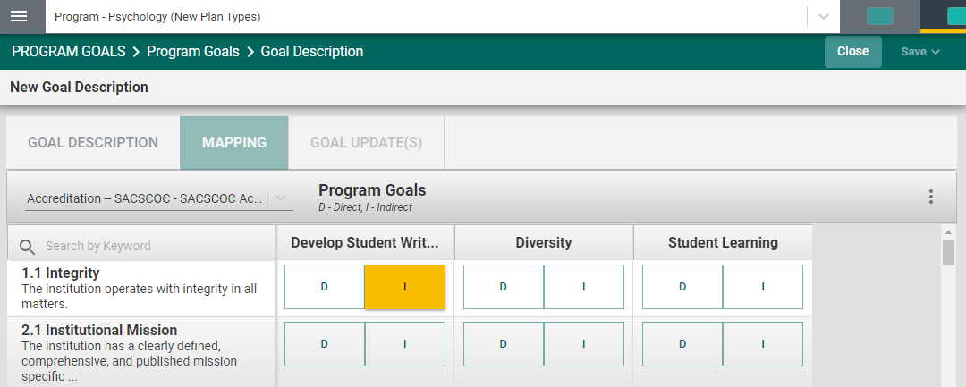

When you have completed the mapping, click the Save drop-down arrow/caret in the top right-hand area of this screen.

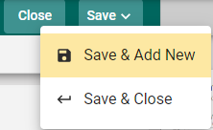 | Save & Add New: Will show all goals that have been entered for mapping and you may continue to map the goals.  Save & Close: Will save your mapping and return you to the main goal screen.

NOTE: For more information on Mapping, return to the Table of Contents and select Mapping.

Entering Goal Updates/Results
The next Tab on the navigation bar for this goal is the GOAL UPDATES(s) page/screen. To add a Goal Update for the goal, click the green circle with the plus (+) sign
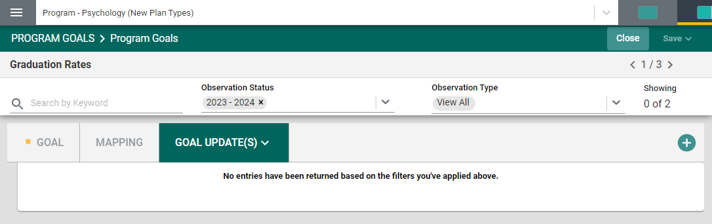
Once you have clicked on the green circle with the plus (+) sign The following card/screen will open. Notice the light green area at the top of the card. This is the information that was entered previously for the goal. You can choose to leave this information available as you enter updates/results, or you can click the Hide icon to the right to hide the information while you work.
Now, begin entering the Status Update/Results for this Goal. First, select the Reporting Period by clicking on the drop-down. Then, click in the text/dialog box to enter the Status Update/Results narrative. Next, click the drop-down to select your conclusion. Finally, use the scroll bar to the right to add any Optional Information and/or Supporting Documents.
To add Supporting Information, click in the text/dialog box. Once you click in the text/dialog box a typical Word toolbar will appear. You have a variety of options such as pasting from a Word document, adding a table, linking to a document outside of the platform, or pasting a graphic/picture from another sources. Note: If there are items available to you in the documents and reports area to the right, you can cut and paste that information into this space.
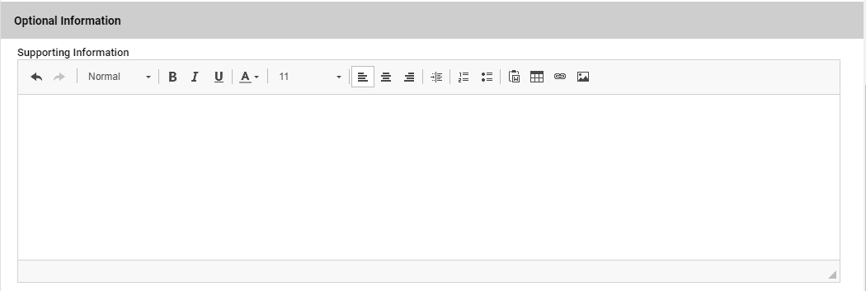

Example:
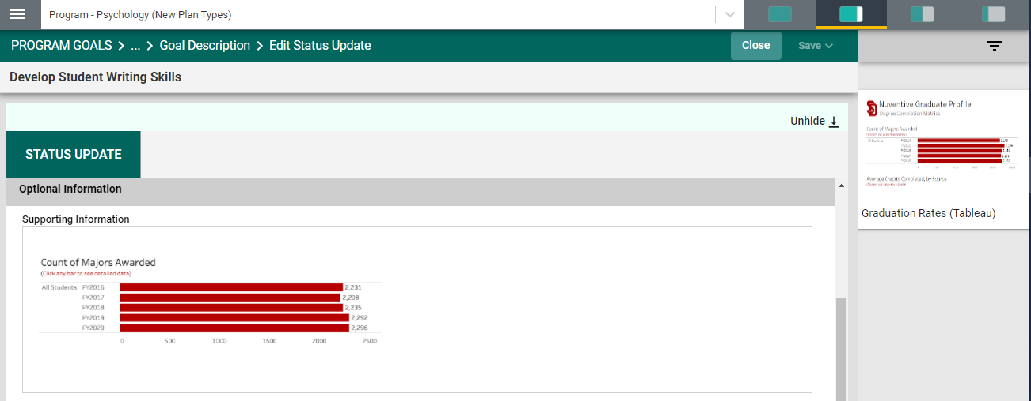

Adding Supporting Documents
To add Supporting Documents, Click the green circle plus + sign

The following screen will appear. Click on the primary folder to open the Document Library folders where this document has been stored.
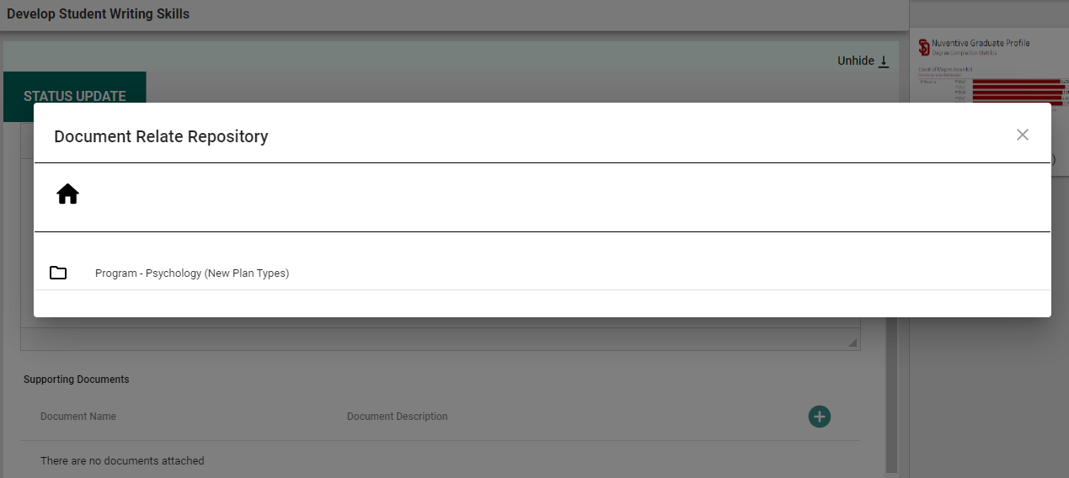

Now select from the folder options available. In this example there is one folder titled General.
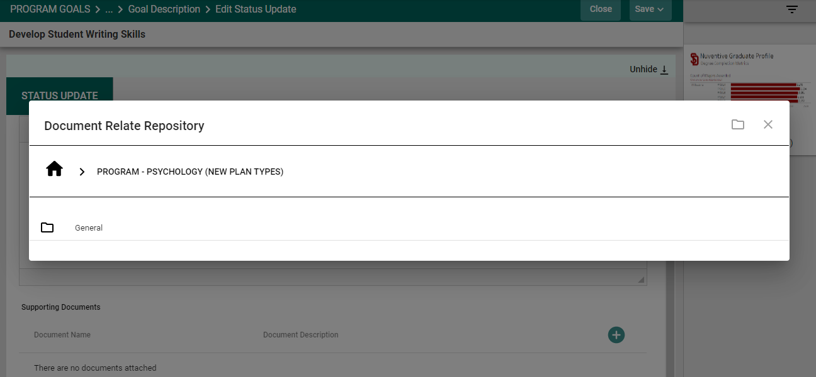
Click the folder name to open that folder. Then, select a file (or files) from that folder by clicking the check-box next to each file you would like to add.
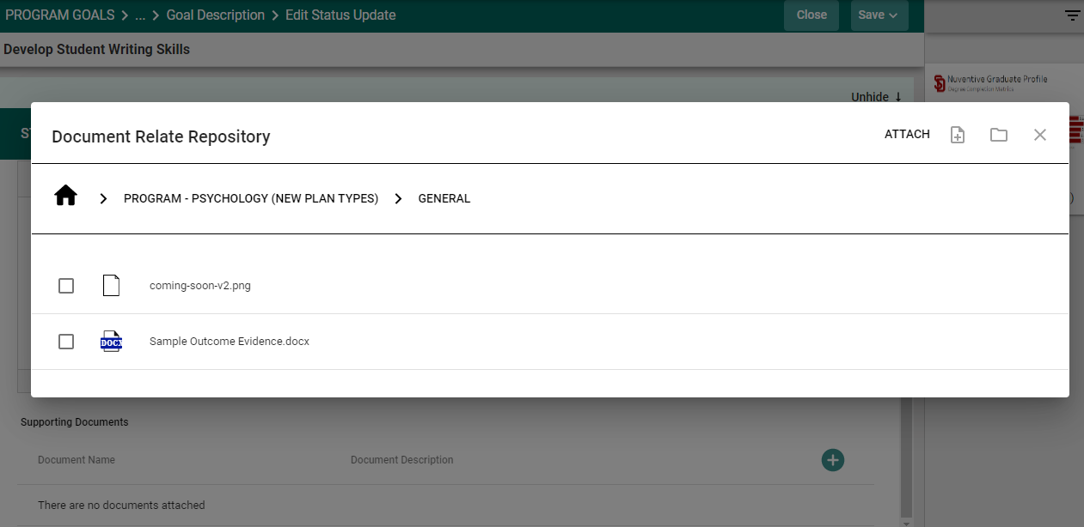

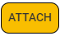
Now select from the from the top right-hand navigation.

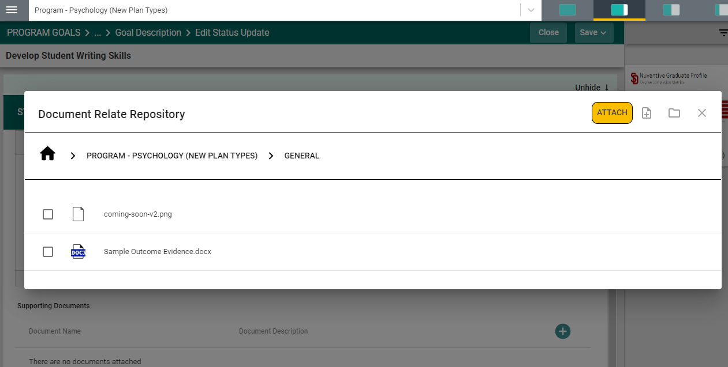

Note: If the folder, or file, is not available in the Document Library/Repository, you can add a folder and/or file, right from this screen by clicking on one of the icons next to the Attach icon.
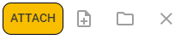
More on the Document Library/Repository later in this Help Guide.

You should now see the file attached as a supporting document.

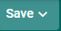
Once you are satisfied with the information you have entered Click and choose to Save & Add New or Save & Close.

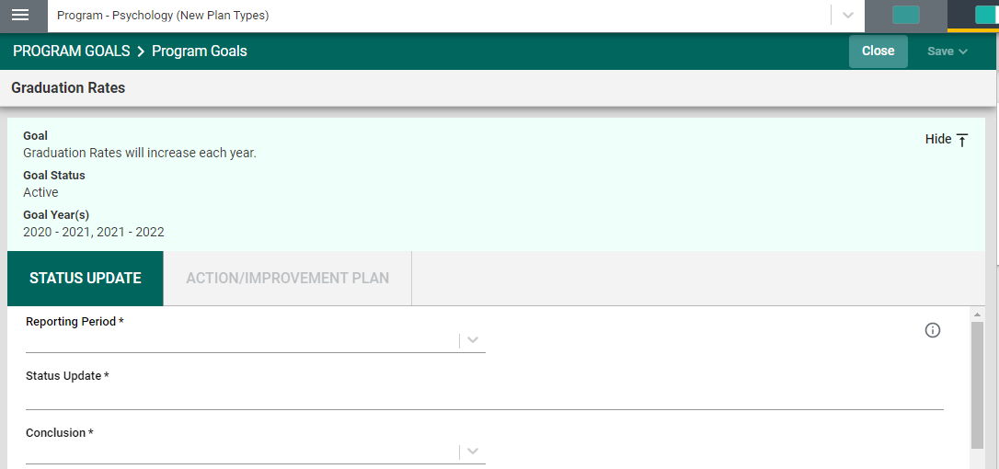
The Save & Add New will allow you to continue adding Updates/Results to other goals. The Save & Close will take you back to the main goal page, or you may continue with this goal by clicking in the Action/Improvement Plan are to the right of the Status Update.
NOTE: You will not be able to add the Action/Improvement Plan information until the Results/Analysis information is saved. Once you have saved the work, proceed to the Action/Improvement Plan by clicking on the ACTION/IMPROVEMENT PLAN tab.
After clicking on the ACTION/IMPROVEMENT PLAN tab the following screen will appear.
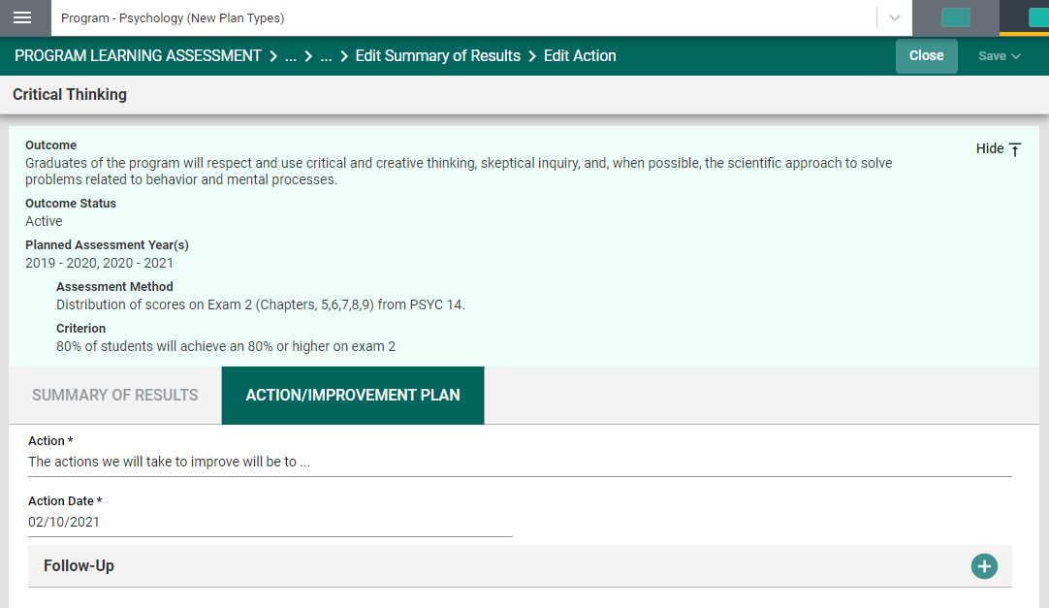
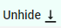
Again, this view of the card will allow you to see the entire plan information. If you would like to hide the plan information, click the Hide icon to the right.
Note: Hiding the plan information is temporary and can be undone by clicking on
Now, complete the Action Plan. Notice that there is also a field for Follow-Up.
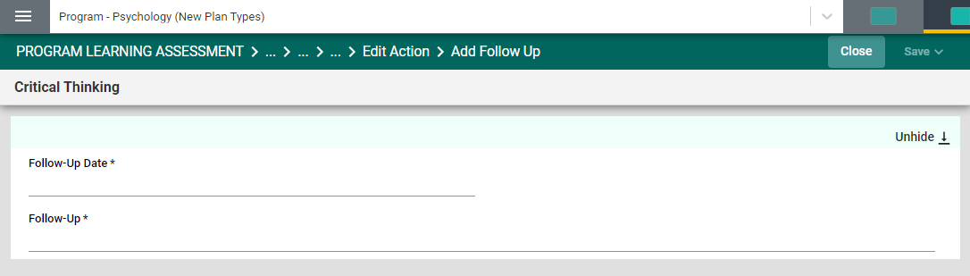
The Follow-up screen will allow you to return later and enter information pertaining to the status of the Action Plan.
You have now completed the ASSESSMENT RESULTS AND ANALYSIS
Now, click Save & Close This will take you back to the main Goal Update(s)/Results screen.
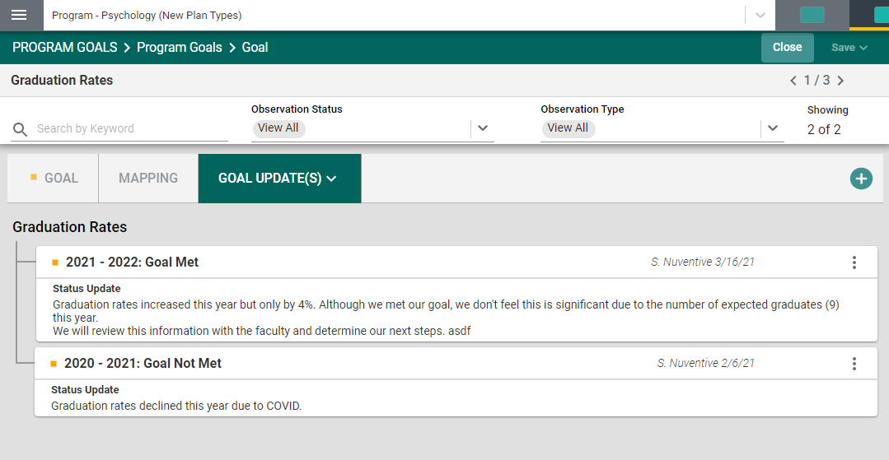

Program Learning Assessment

PROGRAM LEARNING ASSESSMENT

The Program Learning Assessment screens are where you will enter your Program Assessment Plans and Results. The Program Plans and Results screens include the: (Outcome, Assessment Method, Mapping, and Results and Analysis). To begin setting up the program assessment plan, you will first enter the program outcome. Click the green circle with the plus (+) sign
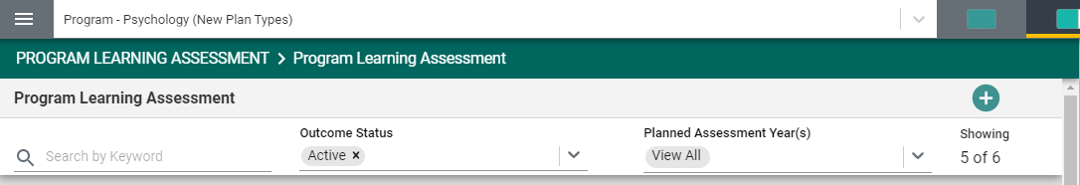

Once you have clicked on the green circle with the plus (+) sign the following card will open.

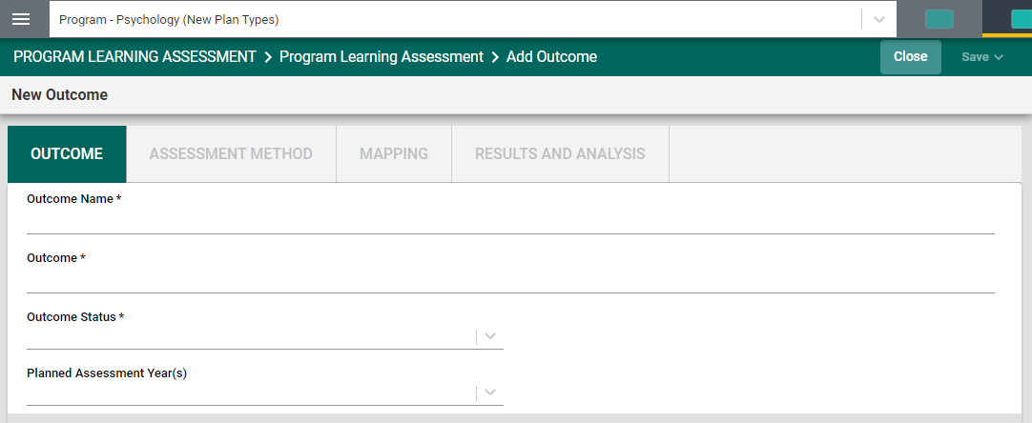
Begin by entering the Outcomes Name*. Notice the Asterisk (*) next to the name of several of the fields. The Asterisk (*) indicates that the field is required, and information must be entered for the card/information to be saved. The Outcome Name should reflect the Outcome. For example: Critical Thinking instead of PLO 1. Continue by selecting from the drop-down caret/arrow to enter the Outcome Status and Planned Assessment Years.

Notice the caret/arrow icon next to some of the fields. This icon indicates that options have been provided from which you are to choose.
For the Outcome Status, options will be Active or Inactive. Select Active if this is a new Outcome and you will be assessing this outcome. Inactive may be chosen if this outcome will not be assessed.
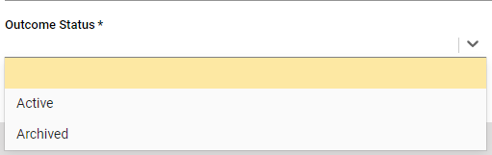

Next, click on the caret/arrow and select the Planned Assessment Year(s). This is the academic year that this plan will be assessed.
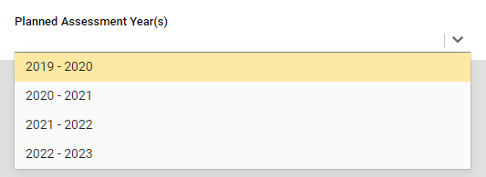
Now, save your work by clicking on the green Save button in the top right-hand corner of the card. By clicking on the Save button, without clicking on the caret/arrow, your work will be saved, and you can continue working on the plan for this outcome.
By clicking on the caret/arrow you will be offered the options to Save & Add New or Save & Close the card. If you have other outcomes to enter, you may select Save & Add New and continue adding outcomes. If you have finished adding outcomes, click the Save & Close.
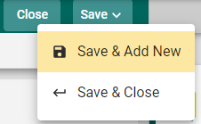

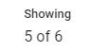
If you click the Save & Close you will see the following screen. In the following example you can see that several Outcomes have been entered and saved. The number of Outcomes is depicted in the top right-hand area of the screen:

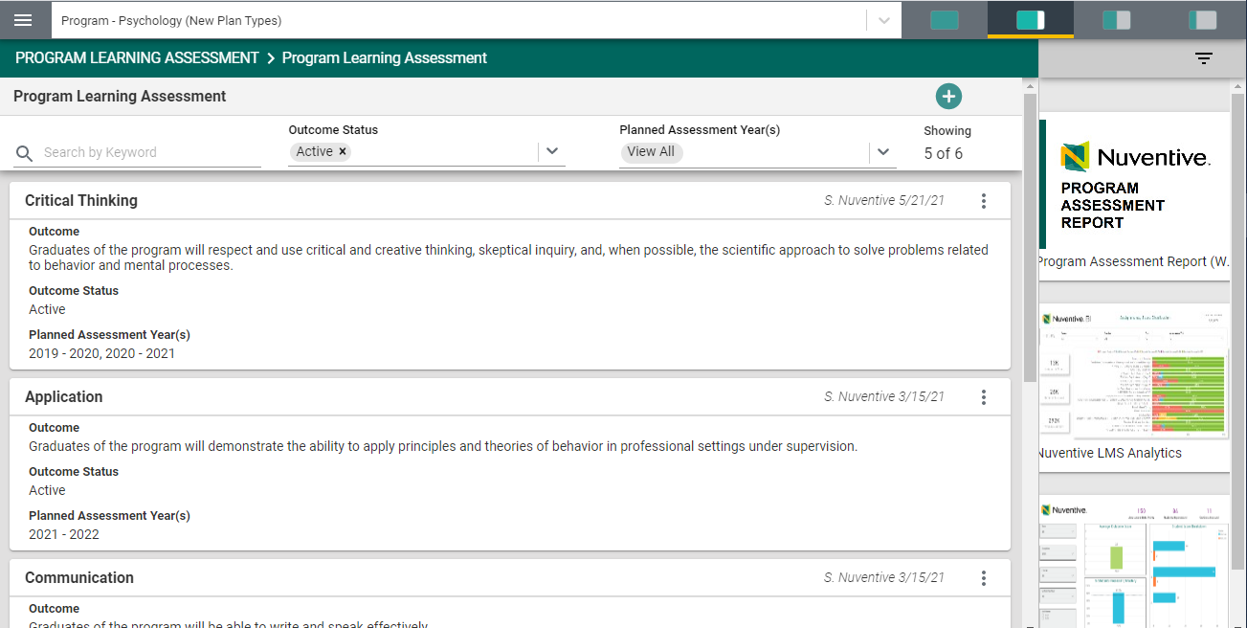

If you have clicked on the Save & Close, have been returned to the screen above, and would like to continue working on the assessment plans (entering Assessment Methods, Mapping, and/or Assessment Results/Analysis), click on the ellipsis to the right on the outcome card where you would like to continue working.
Clicking on the ellipsis will allow you to Open the outcome card, View/Print, or Delete the outcome. Keep in mind that if you delete the outcome, you will also be deleting any results that have been entered for that outcome.

Now that you have entered the Program Learning Outcome, Click the ASSESSMENT METHOD tab to enter an Assessment Method for that Outcome.

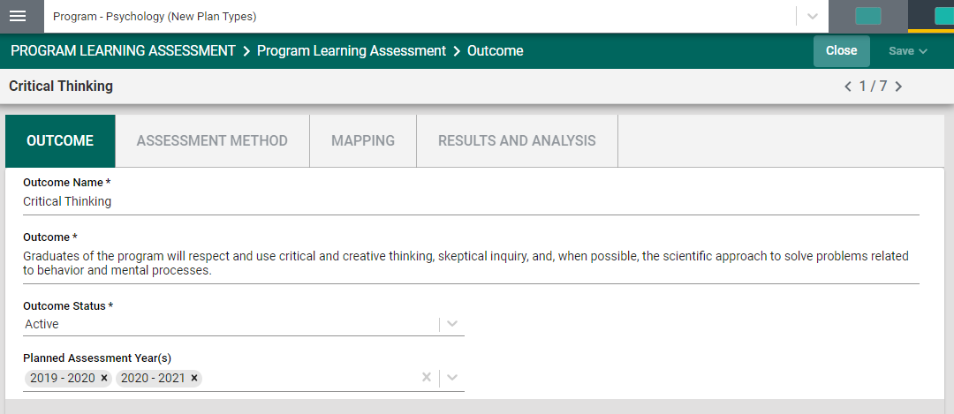

Once you have clicked on the ASSESSMENT METHOD tab you will see the following screen.

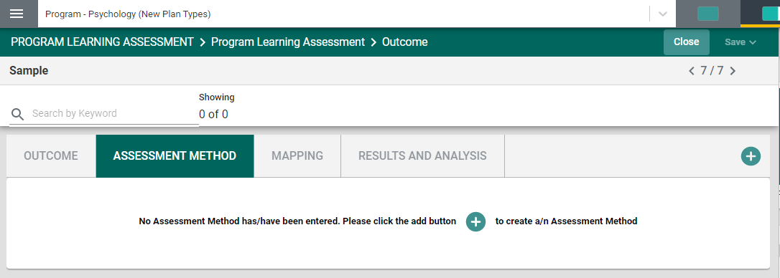
To begin entering an Assessment Method click the green circle with the plus (+) sign.

The following screen will open:
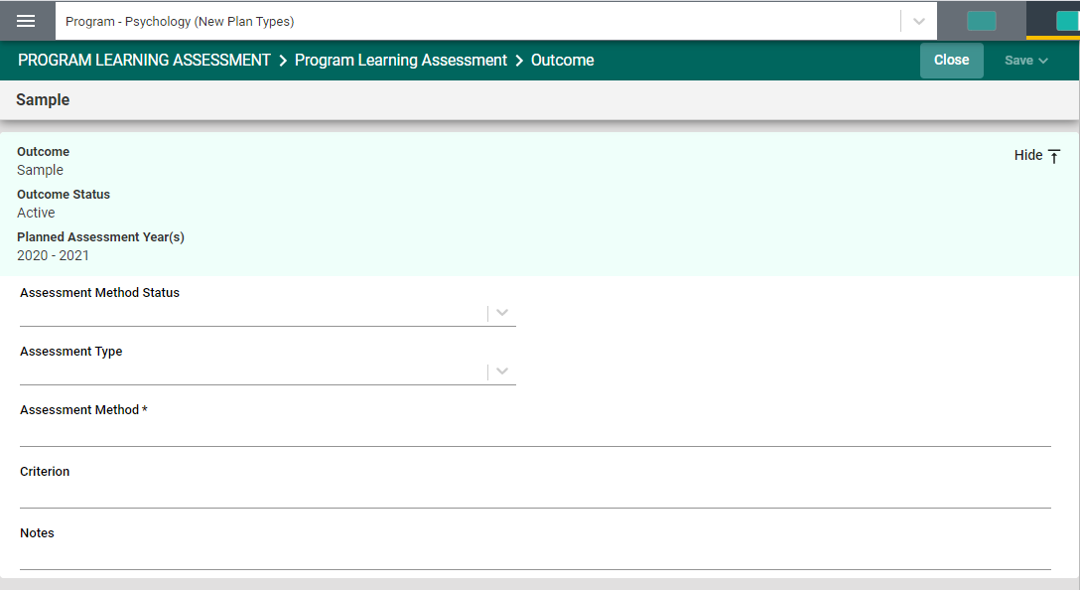
Complete each field: Assessment Method Status, Assessment Type, Assessment Method, Criterion, and Notes.
Notice the caret/arrow icon next to some of the fields. This icon indicates that options have been provided from which you are to choose.
For the Assessment Method Status, options may be Active or Inactive.
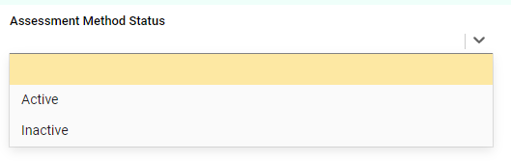
Select Active if this is a new Outcome and you will be assessing this outcome. Inactive may be chosen if this outcome will not be assessed.

Next, select the Assessment Type from the drop-down.
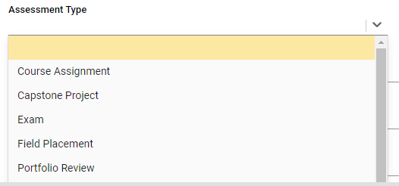
The selections may include Direct or Indirect, and/or you may see a list of specific assessment types to choose from. Select the Assessment Method Type you plan to use for assessing this outcome.
Next, enter the Assessment Method.

Now, save your work by clicking on the green Save button in the top right-hand corner of the card. By clicking on the Save button, without clicking on the caret/arrow, your work will be saved, and you can continue working on the plan for this outcome.
By clicking on the caret/arrow you will be offered the options to Save & Add New or Save & Close the card. If you have other assessment method to enter, you may select Save & Add New and continue adding assessment methods. If you have finished adding assessment methods, click the Save & Close.

Once you have finished adding the assessment methods for each of the outcomes, and have clicked the Save & Close, the following screen will appear showing the assessment methods that have been entered.
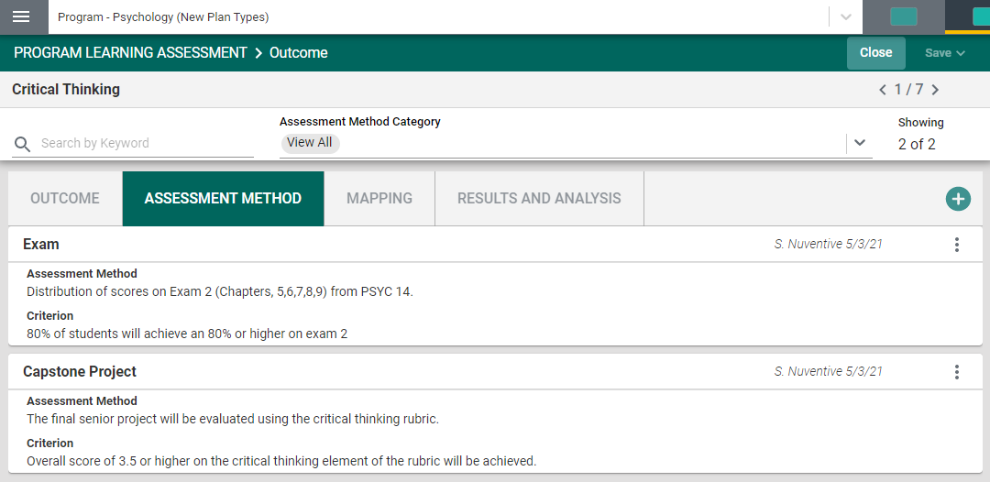
When you have completed adding assessment methods, you may continue to the Mapping screens by clicking on the MAPPING tab. Help information for the Mapping screens is located in another section of this Help Guide. Return to the Table of Content and select Mapping for help.

Entering Program Assessment Results and Analysis

To enter the assessment results, and the analysis of those results, click on the RESULTS AND ANALYSIS tab.
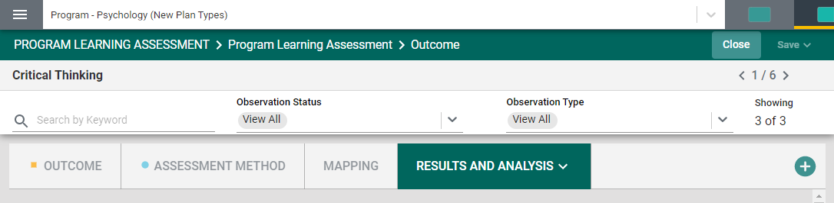
If a new Result and Analysis is being added for an assessment method, click on the green circle with the plus (+) sign
Once you click on the green circle with the plus (+) sign the following information will appear allowing you to choose the assessment methods that have been previously entered for assessment.
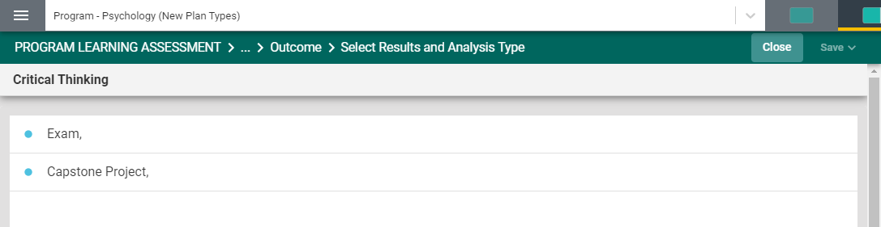

Now, select the assessment method where you would like to enter the results and analysis. For this example, Exam has been selected. The following card will open.
This view of the card will allow you to see the entire plan information. If you would like to hide the plan information, click the Hide icon to the right.

Note: Hiding the plan information is temporary and can be undone by clicking on

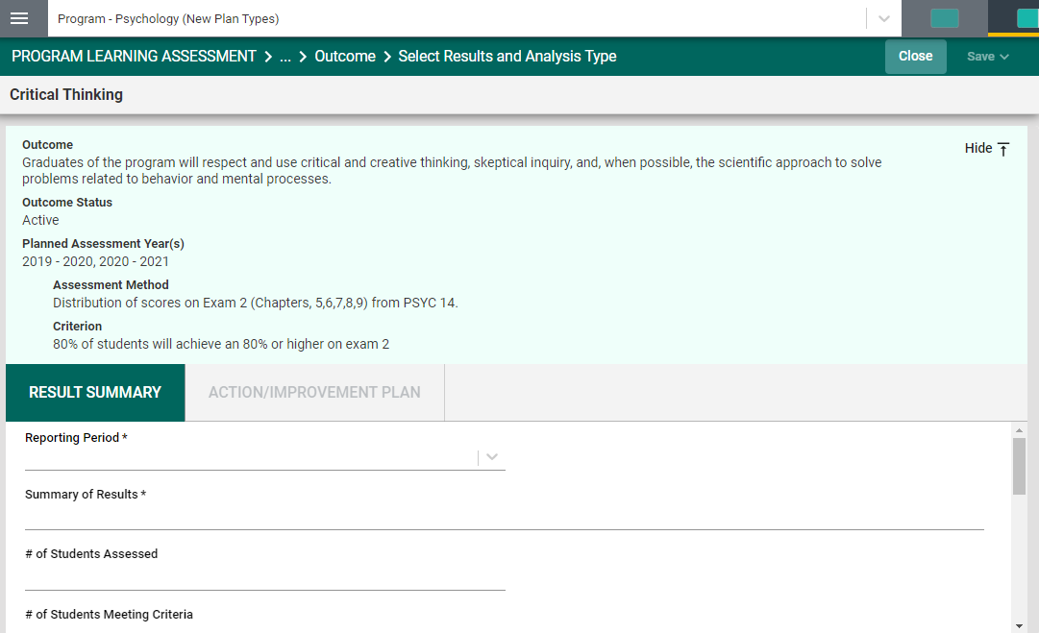
If you have hidden the plan information the card will look like the following:
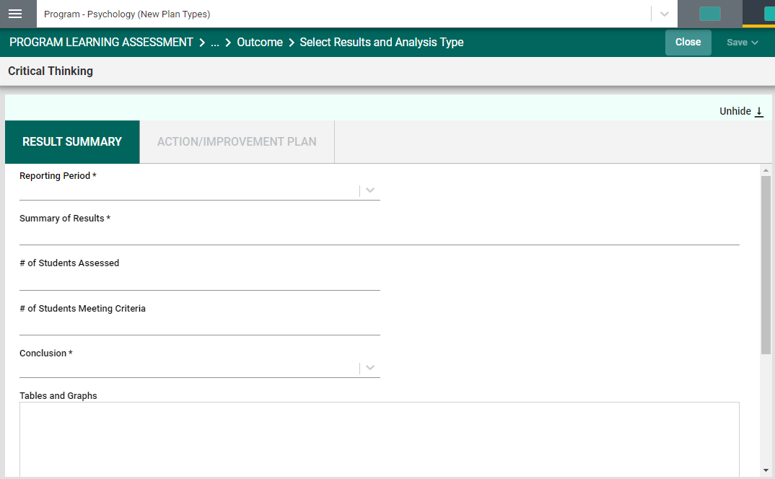
Now, enter the results and analysis. The first entry will be the Results Period. Notice the Asterisk (*) next to the name of the field. Note: wherever you see the Asterisk (*) the information is required, and you will not be able to Save the information until this information has been entered. Also, notice that there is a caret/arrow to the right of the field. Clicking any caret/arrow will open a drop-down where you will select from the choices provided. See example below.

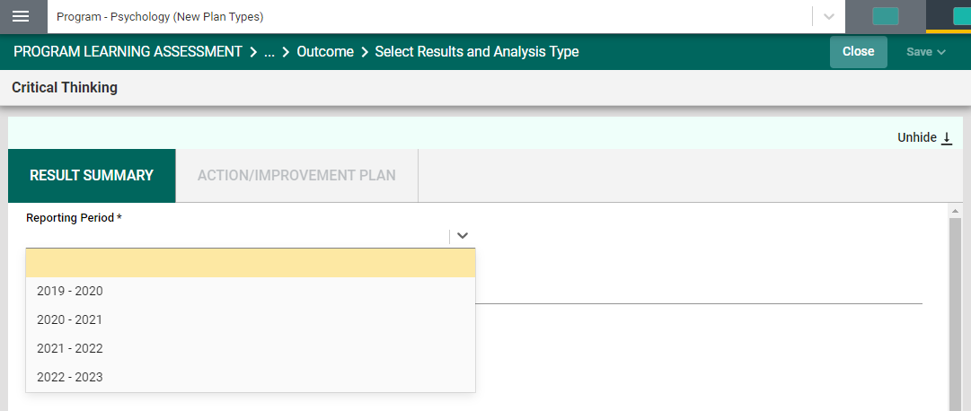
Continue this process of entering information through to the Conclusion field. When you have reached the Table and Graphs field, clicking in the text box will open options for entering text in that box. Click in that text box now to see the options as depicted below.
Notice that the text box now has a tool bar, similar to a Word document toolbar where you can change text, cut and paste from a Word document, insert a table, link to an outside source (URL), add a graphic/picture, and/or include a link to a document in the document library. You can also cut and paste from any document in the right-hand panel.
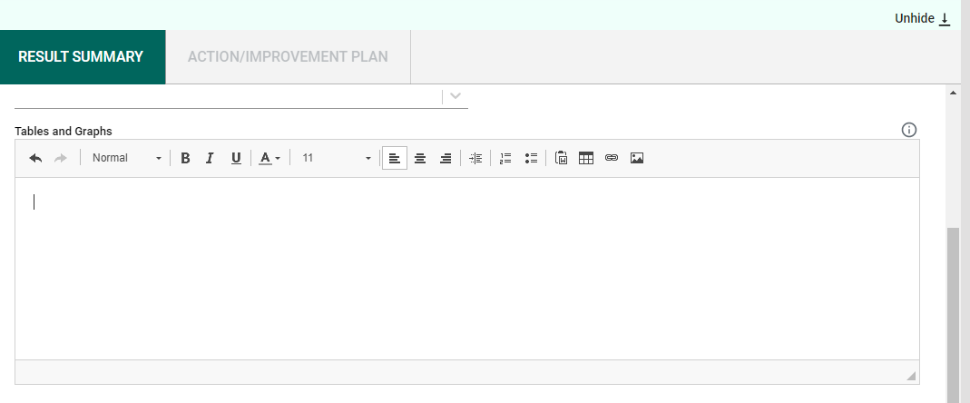

Example: Graphic cut & pasted from PowerBI Report in the right-hand panel.
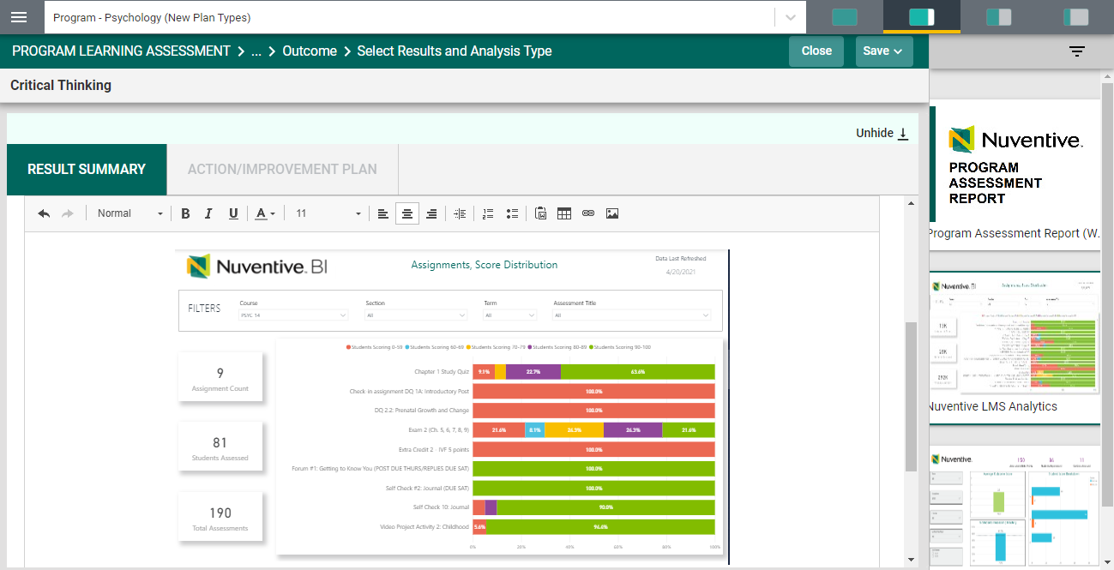
Remember to Save your work!

The next field, Supporting Documents, will allow you to select documents from the Document Library/Repository and attach them to the results report.

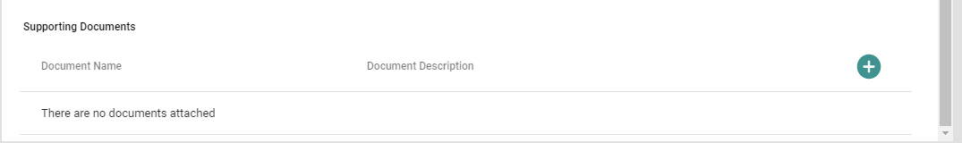
To add an item from the Document Library/Repository, begin by clicking the green circle with the plus (+) sign.
The following screen will open and allow you to select a folder.
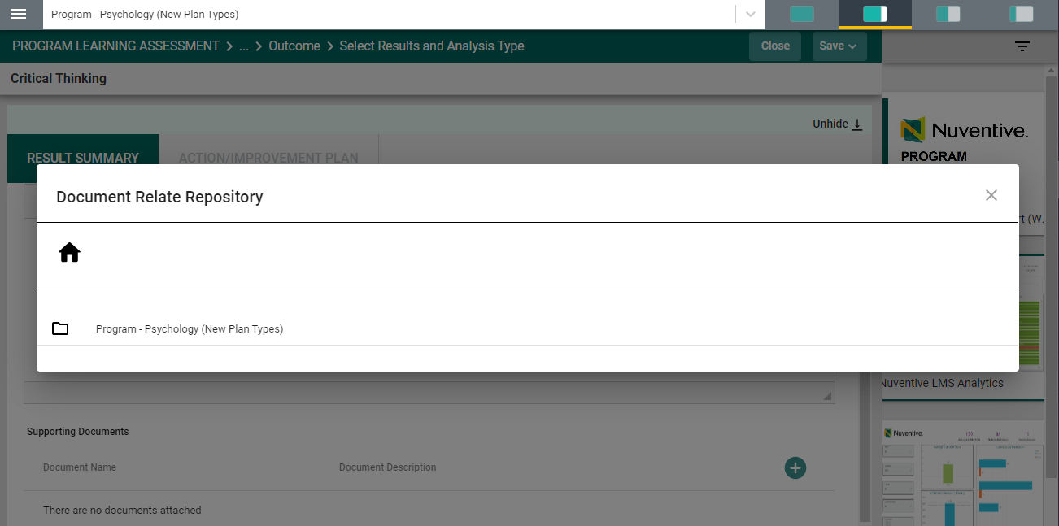
Select a folder where you have stored the file by clicking on the folder. The folder will open and allow you to select a file.
Locate the file that you would like to include in your results/analysis. You may select more than one file by clicking on the check box next to each file.
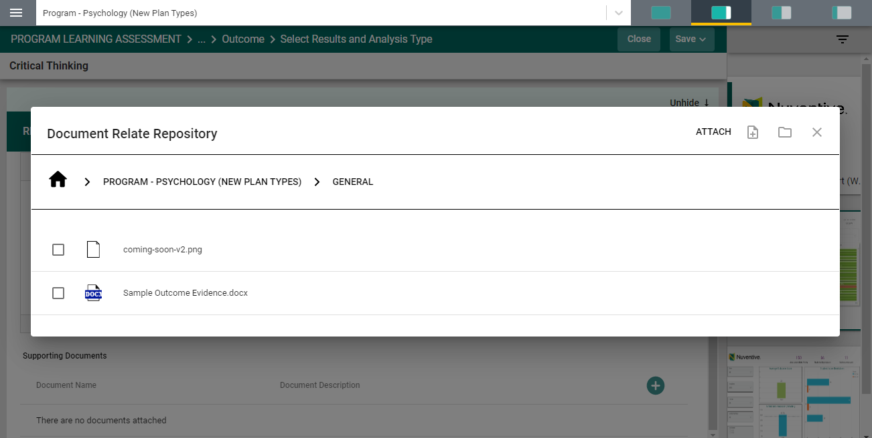
Once you have selected the file(s) that you would like to include, click on the Attach icon in the top right-side of the card. Notice that the Attach icon turns yellow.
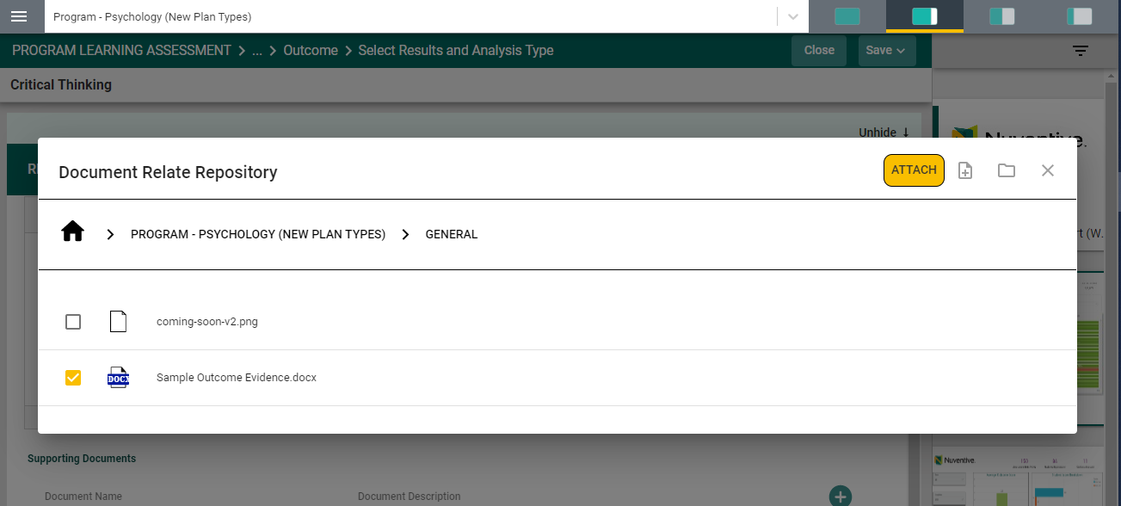
Note: If the file you are wanting to include in your results in not among the files listed, you can add a file to the library/repository by clicking on the file + icon to the right on the Attach icon. 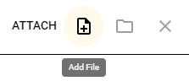 Clicking on this icon will allow you to select a file from your computer.

Once you have clicked on the icon, the following dialog box will open. Click on the Choose Files button and select a file from your computer.
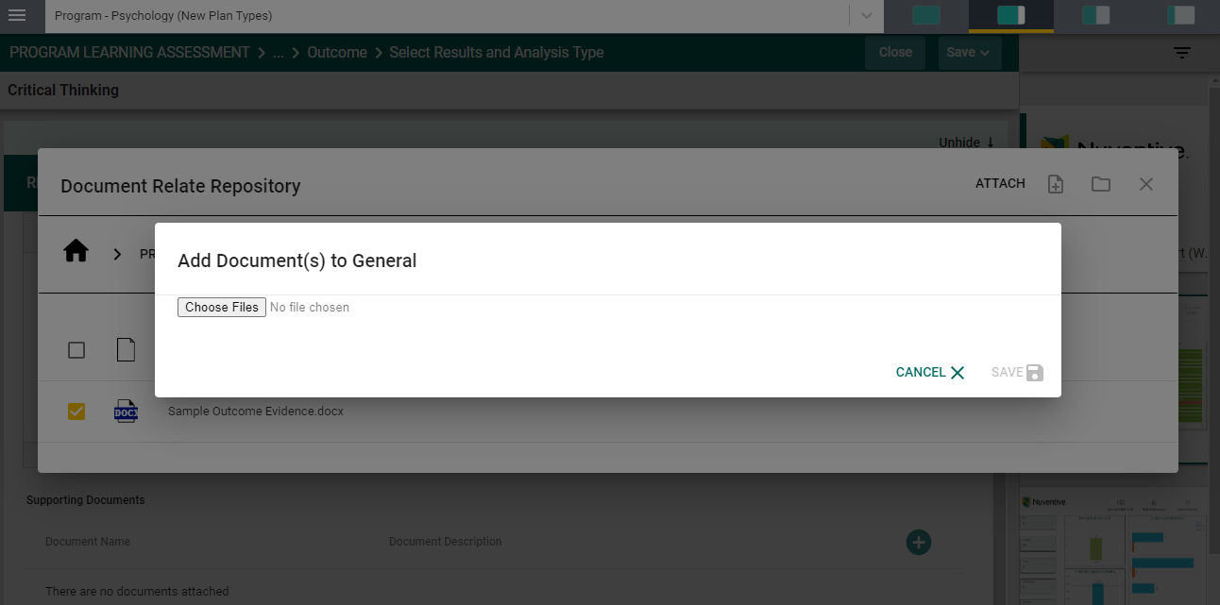

The file will now appear in the in the dialog box. Now click Save to upload the file.
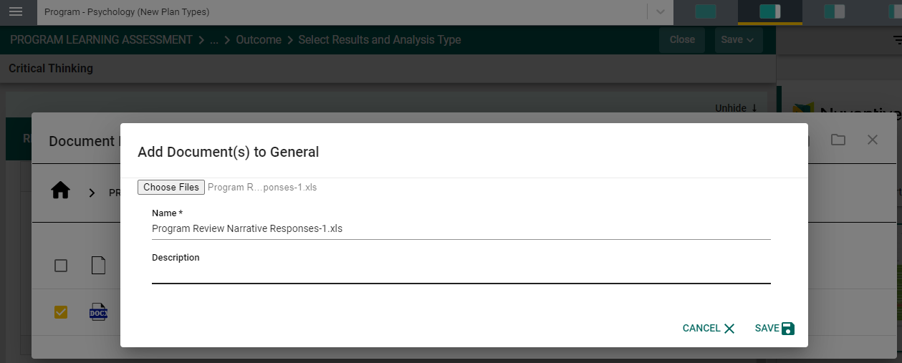
The file will now appear in the list of files and is ready for you to attach to your results/analysis.
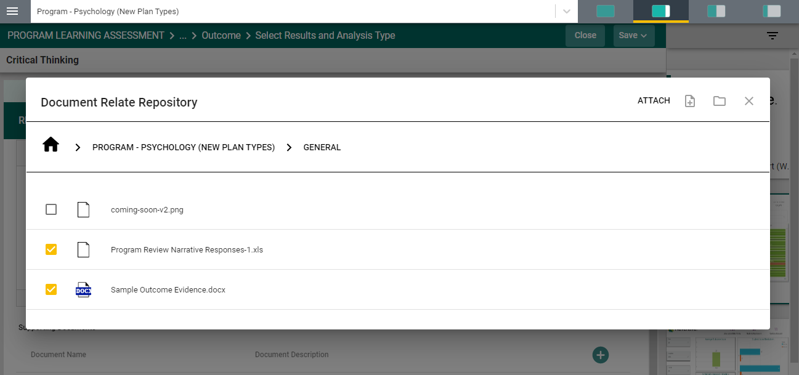
Again, once you have selected the file(s) that you would like to include, click on the Attach icon in the top right-side of the card. Notice that the Attach icon turns yellow.
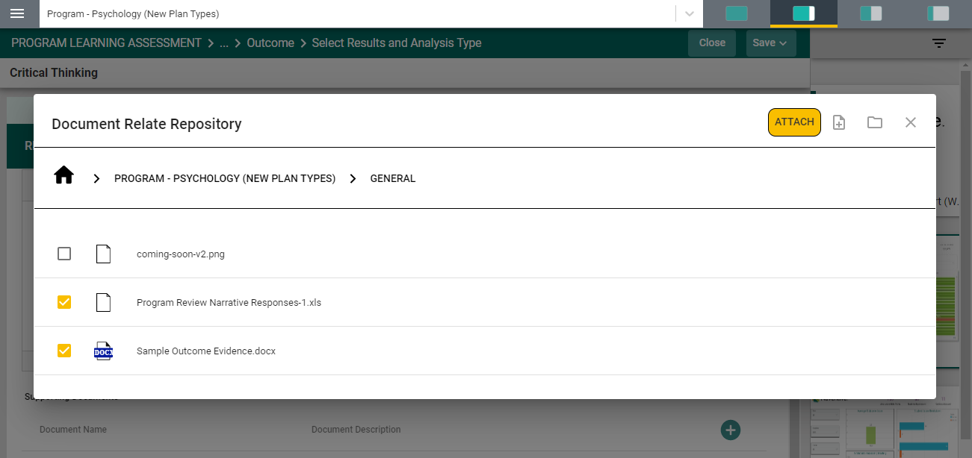
The files are now attached to the results/analysis for this assessment method.
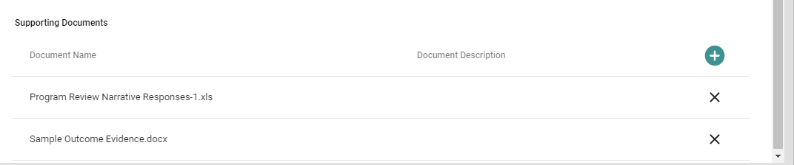
The SUMMARY OF RESULTS is now complete.
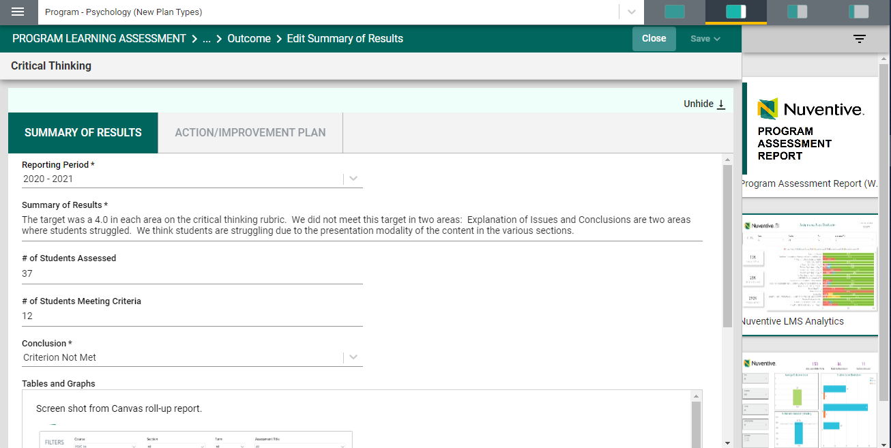

Now, save your work by clicking on the green Save button in the top right-hand corner of the card. By clicking on the Save button, without clicking on the caret/arrow, your work will be saved, and you can continue working on the plan for this outcome.
By clicking on the caret/arrow you will be offered the options to Save & Add New or Save & Close the card. If you have other assessment method to enter, you may select Save & Add New and continue adding assessment methods. If you have finished adding assessment methods, click the Save & Close.

NOTE: You will not be able to add the Action/Improvement Plan information until the Results/Analysis information is saved. Once you have saved the work, proceed to the Action/Improvement Plan by clicking on the ACTION/IMPROVEMENT PLAN tab.
After clicking on the ACTION/IMPROVEMENT PLAN tab the following screen will appear.
Again, this view of the card will allow you to see the entire plan information. If you would like to hide the plan information, click the Hide icon to the right.
Note: Hiding the plan information is temporary and can be undone by clicking on

Now, complete the Action Plan. Notice that there is also a field for Follow-Up.
The Follow-up screen will allow you to return later and enter information pertaining to the status of the Action Plan.
You have now completed the Assessment Results and Analysis!

Course Assessment

COURSE ASSESSMENT

If your institution has chosen to conduct Course Assessment in the Nuventive Improvement Platform you will see the Course Assessment menu heading in the Main Menu. Click the Menu heading. The following screen will appear.

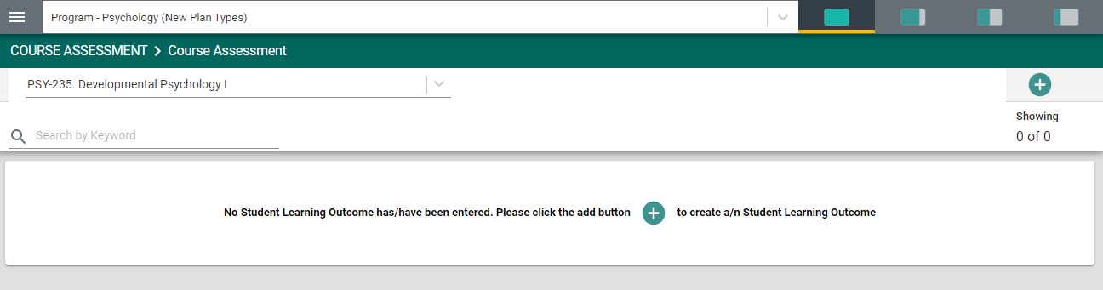
To begin, select the course from the drop-down, for which Student Learning Outcomes (SLOs) will be entered.
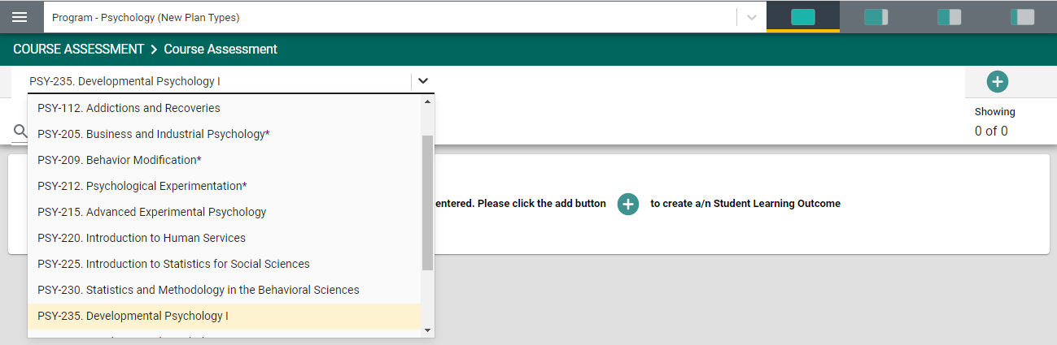
Once the course has been selected, click the green circle with the plus sign (+)
in the center of the card, or in the top right-hand corner of the card.

The following card will open.
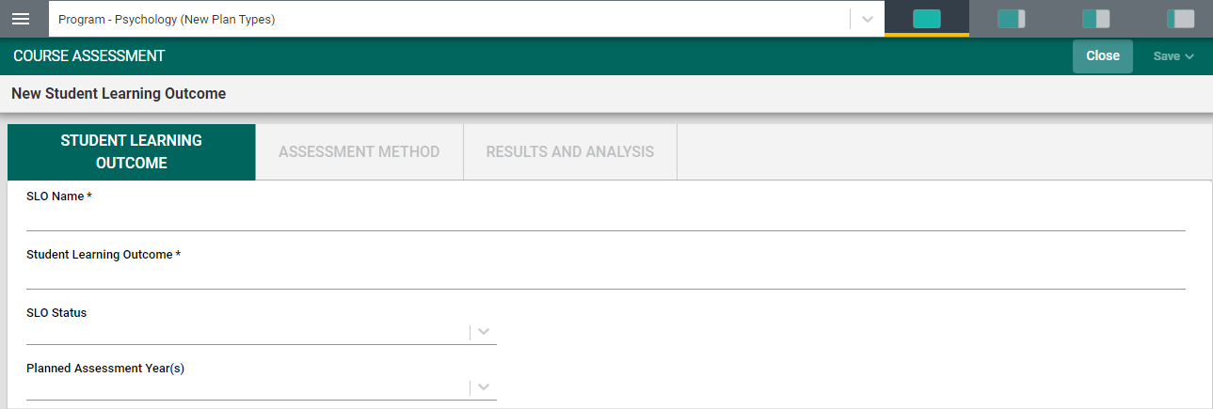
Begin by entering the Student Learning Outcome (SLO) Name. We recommend that you refrain from using only SLO 1, SLO 2, etc. to avoid confusion if/when SLOs will be archived. Instead, provide a unique name that represents the Student Learning Outcome in the next field. For Example: SLO 1 - Logic of the Scientific Method. Notice the Asterisk (*) next to the field name: SLO Name *. Anytime you see an Asterisk (*), the field is required, and you will not be able to save your work until this filed is completed.
Next, enter the Student Learning Outcome. Example: students will be able to identify key elements of the scientific method as applied to mental processes and behavior.
Then, select the SLO Status from the drop-down. The choices are: Active or Archived. Active means the SLO is being assessed. Archived means that the SLO has been taken out of use. NOTE: Once results have been entered for an SLO do NOT delete the SLO. If the SLO is deleted ALL results that have been entered for that SLO will also be deleted.
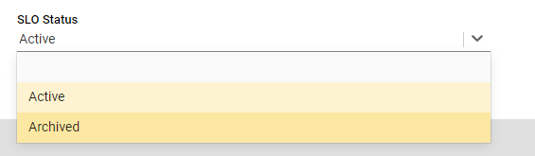
Next, select from the Planned Assessment Year(s) drop-down.
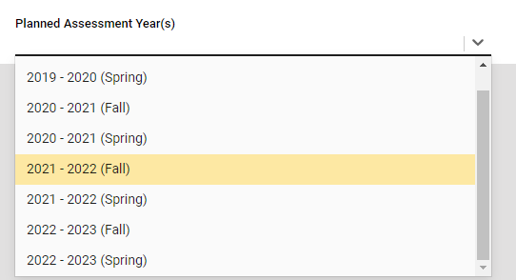
The Planned Assessment Years listed will vary based on what the institution has selected. For the example above, you can see that Spring and Fall have been included. Your drop-down list may only include the years. You will want to select the assessment years that this SLO will be assessed. NOTE: This is a multi-select field and you can select multiple years if you plan to assess this SLO during those timeframes.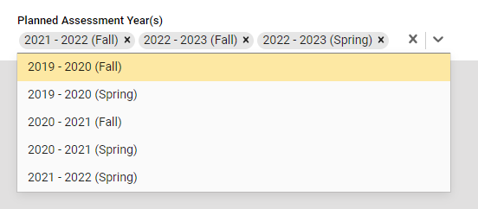

Once you have completed this card, your card should look similar to the one below.

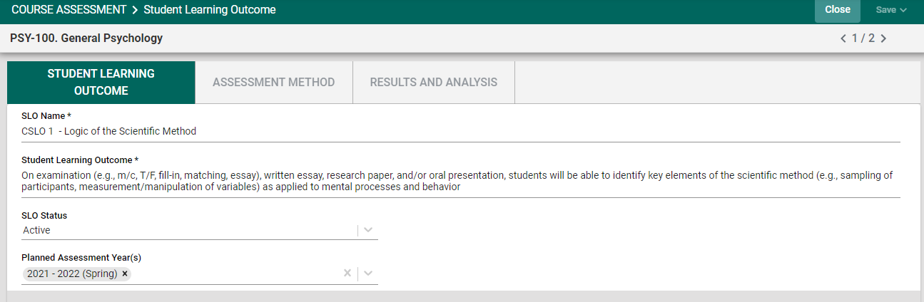

Once you have completed entering the SLO information, SAVE your work by clicking on the SAVE button in the top right-hand corner of the card. Notice that the SAVE button also has a Caret/Arrow next to the word “Save.” If you click on the word “Save” you will have saved the work and can continue to the ASSESSMENT METHODS tab, or RESULTS AND ANALYSIS tab.
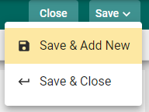
If you click the Caret/Arrow on the SAVE button you are provided with the options to Save & Add New or Save & Close this SLO. If you have additional SLOs to add, click the Save & Add New. If you have finished adding SLOs and would like to return to the main Course Assessment Screen, click the Save & Close.

Save and Close will take you back to the main Course Assessment Screen where you will see all SLOs that have been entered.
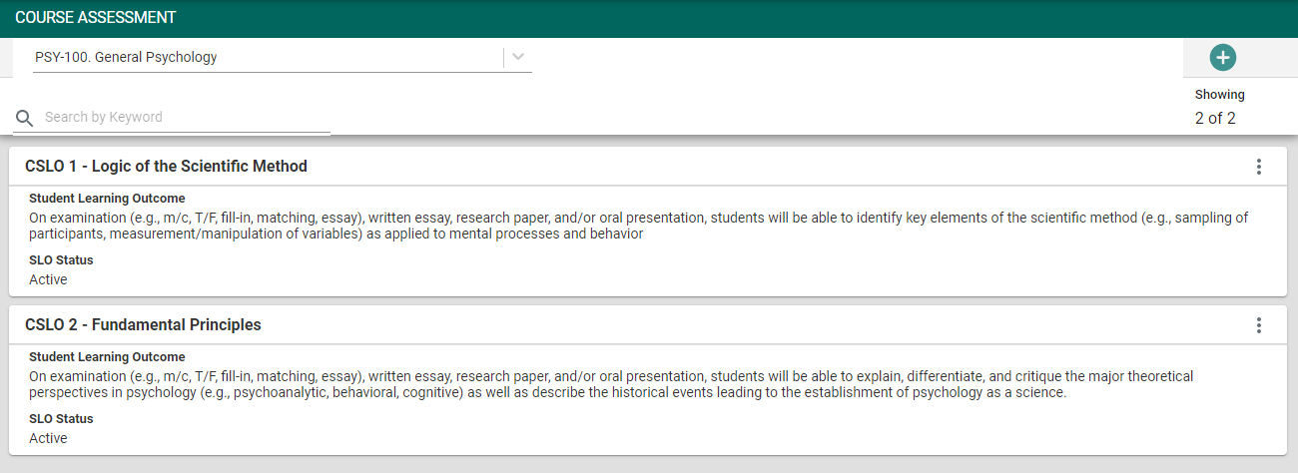

Save and Add New will provide a new card for you to continue adding SLOs. Notice that in the upper right-hand side of the card above, under the green circle with the plus sign (+), you see 2 of 2. This is an indicator of the number of Student Learning Outcomes (SLOs) that have been entered. Once you open the Outcome, this same indicator will allow you to see which Outcome you are currently viewing and working on.

The next step in the planning process is to add the Assessment Method for each SLO.
From the main Course Assessment Screen, select the SLO where you would like to enter the Assessment Method, by clicking on the ellipsis to the right of the SLO card.
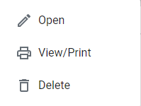
The following dialog box will appear.
Open will open the SLO card.
View/Print will allow you save the
Information to your computer for printing. Delete will delete the SLO and all information connected to that SLO, including any results that have been entered.

Now, click Open. You will now see the SLO information that was previously entered.
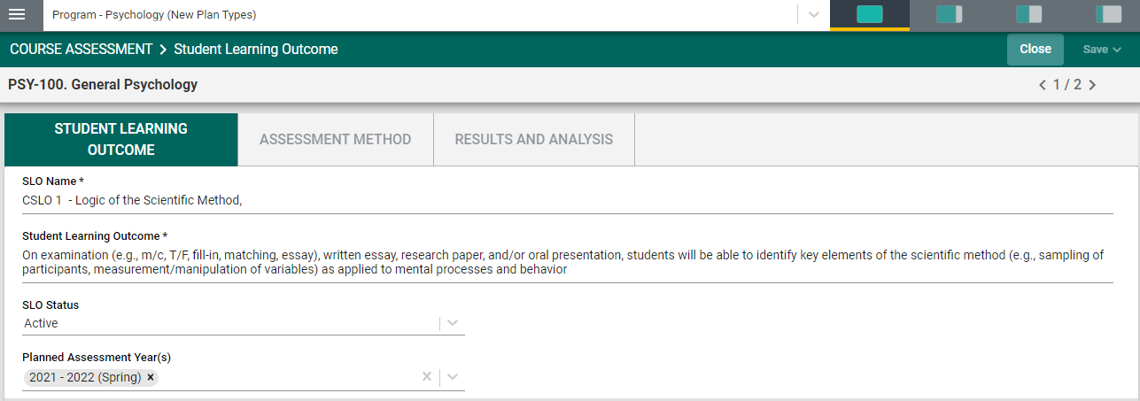
Next, click the ASSESSMENT METHOD tab.
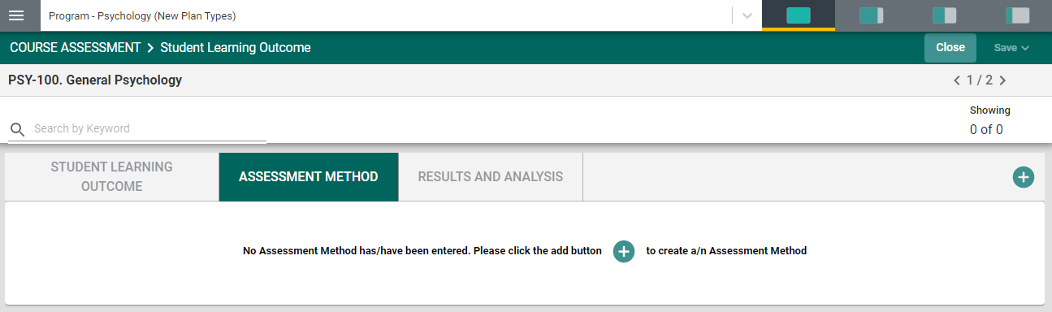

To begin entering the assessment method for this SLO, click the green circle with the plus (+) sign in the center of the card, or in the top right-hand corner.
The following card will open.
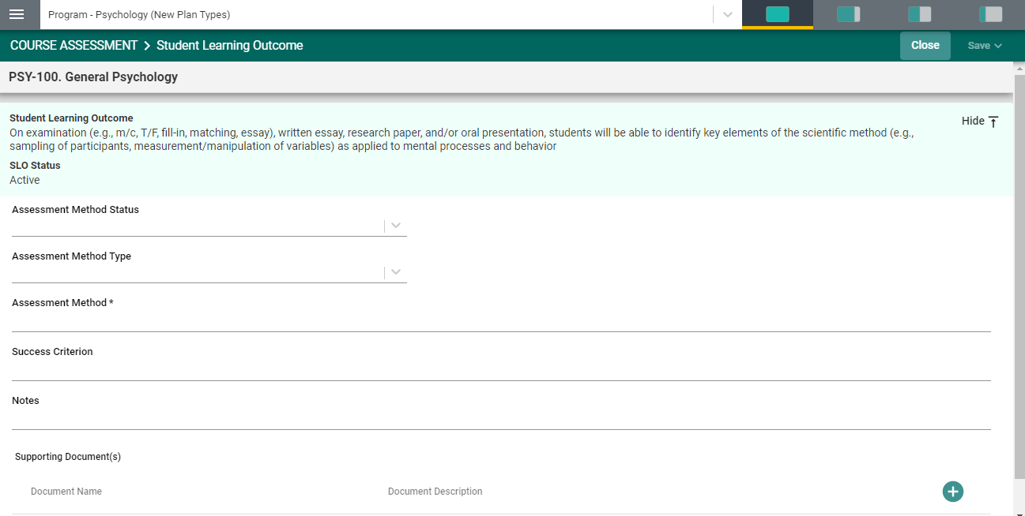
Notice the light green area at the top of the card. This is the information that was entered previously for the SLO. You can choose to leave this information available as you enter the assessment method information, or you can click the Hide icon to the right to hide the information while you work.
Now, click the caret/arrow to the right of the Assessment Method Status. This will allow you to select from the options provided.
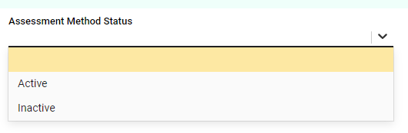
If this is a new SLO, and you plan to assess this SLO, click Active. Inactive means that the SLO will not be assessed and will be hidden from this page.

Next, select the Assessment Method Type. Your choices may differ from this example. You might see Direct and Indirect. Regardless, select from the choices that your institution has provide. NOTE: You can only select 1 Assessment Method Type. If you plan to Assess this SLO by additional Assessment Methods, you will be provided with that option when you are ready to SAVE this card.
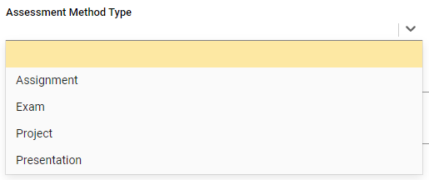
In the next field, Assessment Method, describe how you plan to assess this SLO.
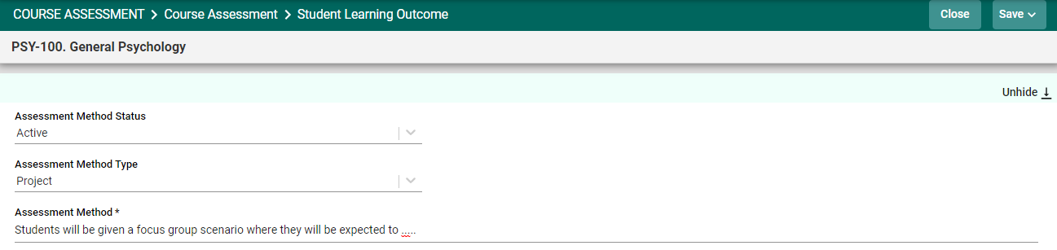

Next, provide the Success Criterion. This will be the Target level of achievement for the group being assessed. Continue entering information for the remainder of the fields for this Assessment Method. Your Institution may have added custom fields to accommodate specific requirements.

Attaching a Document to the Assessment Method
Now that you have entered an Assessment Method for this SLO, you can attach a document to the Assessment Method. For example, if the means of evaluation for this method is a rubric, you can attach the rubric to the Assessment Method.

To add Supporting Documents, Click the green circle plus + sign

The following screen will appear. Click on the primary folder to open the Document Library folders where this document has been stored.

Now select from the folder options available. In this example there is one folder titled General.

Click the folder name to open that folder. Then, select a file (or files) from that folder by clicking the check-box next to each file you would like to add.

Now, select from the from the top right-hand navigation.

Note: If the folder, or file, is not available in the Document Library/Repository, you can add a folder and/or file, right from this screen by clicking on one of the icons next to the Attach icon.
More on the Document Library/Repository later in this Help Guide.

You should now see the file attached as a supporting document.

You have now completed the ASSESSMENT METHOD for that SLO. Remember to SAVE your work! You may continue adding assessment methods for each of the SLOs, or you may Save and Close to return to the main COURSE ASSESSMENT screen.

Entering Course Assessment Results and Analysis

To begin entering the RESULTS AND ANALYSIS for a Course Student Leaning Outcome (CSLO), locate the CSLO where you would like to enter the results. Open the card by clicking on the ellipsis to the right of the CSLO card.

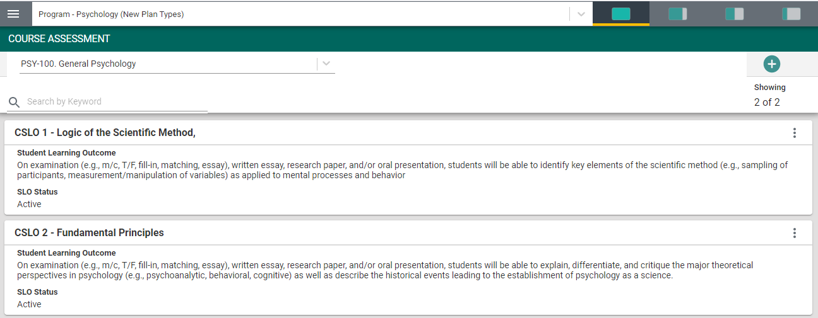

Once you have clicked on the ellipsis the following menu will appear. Now, click Open. 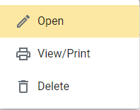
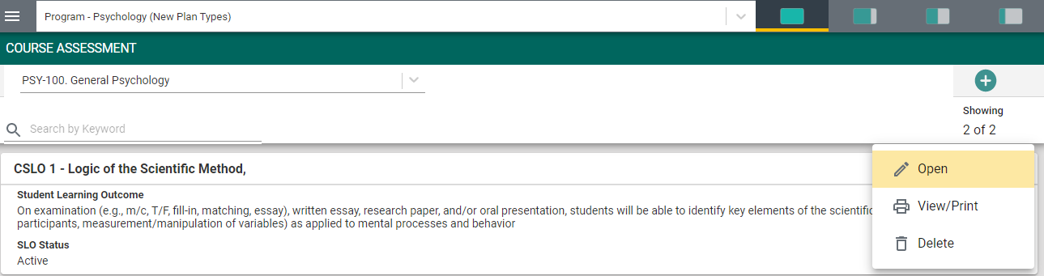

That specific STUDENT LEARNING OUTCOME screen will open – as seen below.
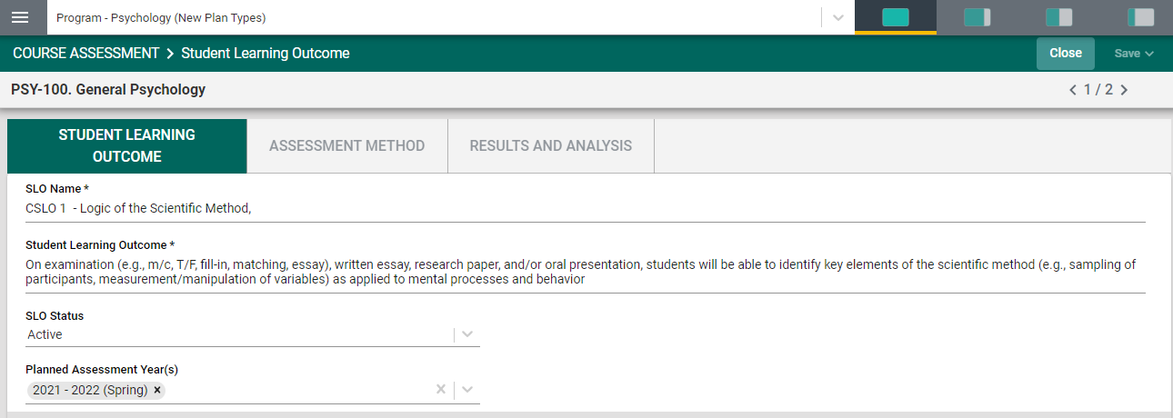
Next, select the RESULTS AND ANALYSIS tab. The following screen will open.
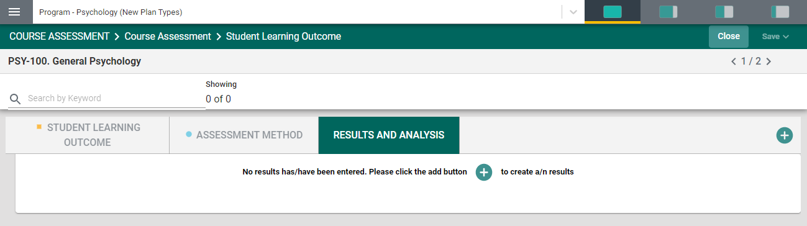
If a new Result and Analysis is being added for an assessment method, click on the green circle with the plus (+) sign
The following screen will open. This view of the card will allow you to see the entire CSLO information. If you would like to hide this information, click the Hide icon to the right.
Note: Hiding the CSLO information is temporary and can be undone by clicking on
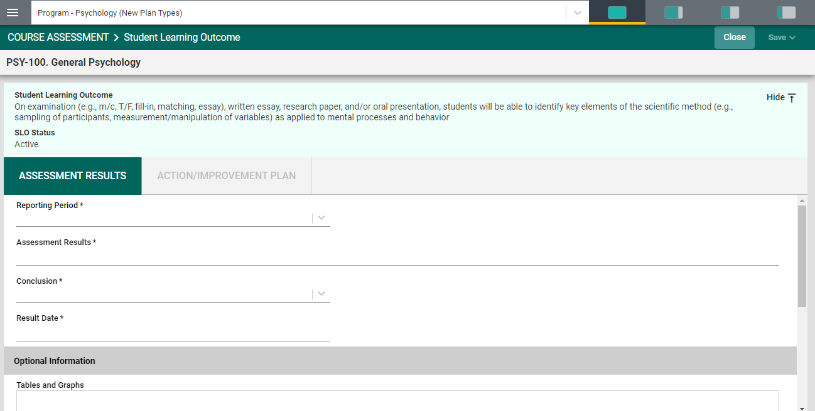
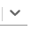
Now, enter the Assessment Results. The first entry will be the Results Period *. Notice the Asterisk (*) next to the name of the field. Note: wherever you see the Asterisk (*) the information is required, and you will not be able to Save the information until this information has been entered. Also, notice that there is a caret/arrow to the right of the field. Clicking any caret/arrow
will open a drop-down where you will select from the choices provided. See example below.
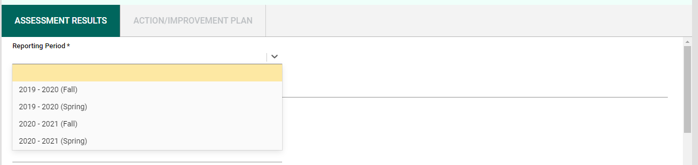
Continue working down the card.
Next, provide the Assessment Results*. Then, select the Conclusion* from the dropdown by clicking on the caret/arrow.
Now, select the Results Date*. This is the date that you have entered this result.
Finally, use the scroll bar to the right to add any Optional Information and/or Supporting Documents.
To add Supporting Information, click in the text/dialog box. Once you click in the text/dialog box the typical Word toolbar will appear. You have a variety of options such as pasting from a Word document, adding a table, linking to a document outside of the platform, or pasting a graphic/picture from another sources. Note: If there are documents available to you in the area to the right, you can cut and paste that information into this space.

Example:

To add Supporting Documents, Click the green circle plus + sign

The following screen will appear. Click on the primary folder to open the Document Library folders where this document has been stored.

Now select from the folder options available. In this example there is one folder titled General.
Click the folder name to open that folder. Then, select a file (or files) from that folder by clicking the check-box next to each file you would like to add.

Now select from the from the top right-hand navigation.

Note: If the folder, or file, is not available in the Document Library/Repository, you can add a folder and/or file, right from this screen by clicking on one of the icons next to the Attach icon.
More on the Document Library/Repository later in this Help Guide.

You should now see the file attached as a supporting document.
Once you are satisfied with the information you have entered Click and choose to Save & Add New or Save & Close.

NOTE: You will not be able to add the Action/Improvement Plan information until the Results/Analysis information is saved. Once you have saved the work, proceed to the Action/Improvement Plan by clicking on the ACTION/IMPROVEMENT PLAN tab.
After clicking on the ACTION/IMPROVEMENT PLAN tab the following screen will appear.
(REPLACE THIS GRAPHIC)
Again, this view of the card will allow you to see the entire plan information. If you would like to hide the plan information, click the Hide icon to the right.
Note: Hiding the plan information is temporary and can be undone by clicking on
Now, complete the Action Plan. Notice that there is also a field for Follow-Up.
(REPLACE THIS GRAPHIC)
The Follow-up screen will allow you to return later and enter information pertaining to the status of the Action Plan.
You have now completed the ASSESSMENT RESULTS AND ANALYSIS

Mapping

MAPPING

Once you have clicked on the MAPPING tab in the Main Menu, the following screen will open. NOTE: Nuventive Mapping is provided for diagnostic and reporting purposes only. All mapping, conducted within the mapping screens (Curriculum Mapping, Goals, Mapping, Outcomes Mapping, etc.) function the same. The only differences are that: 1. You will select the type of mapping from the drop-down, 2. The indicators may change.

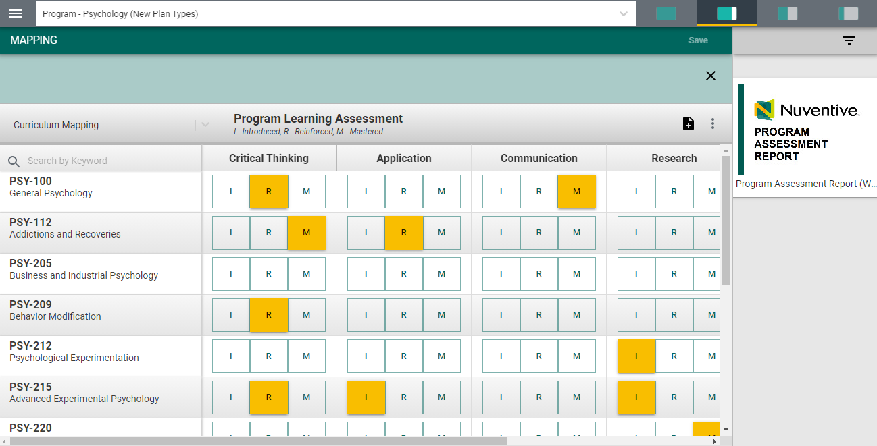

Curriculum Mapping
Begin by selecting Curriculum Mapping from the drop-down to the left of the screen as depicted below.
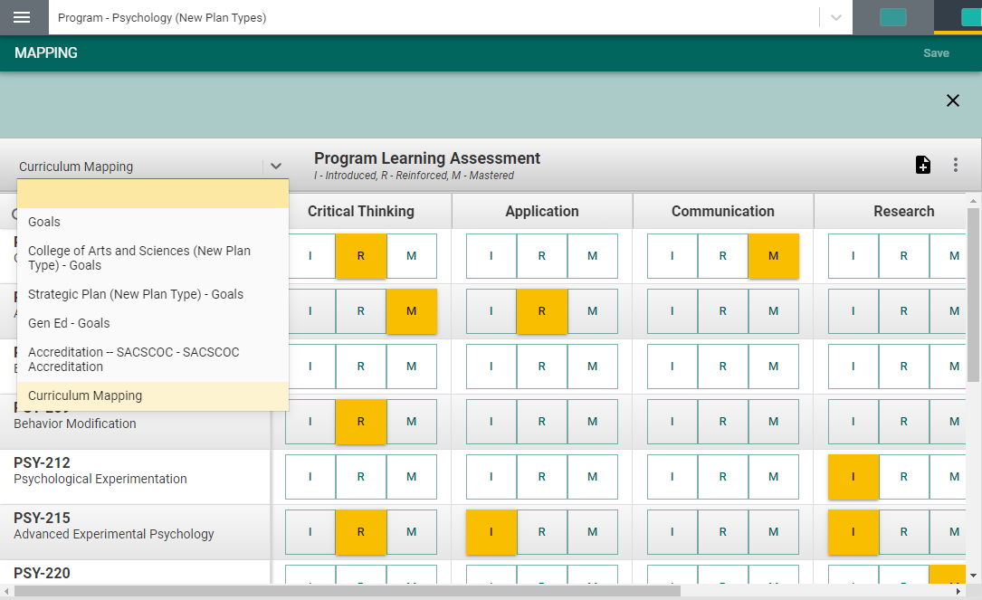

Next, notice that the courses aligned to this program are listed in the left-hand column.
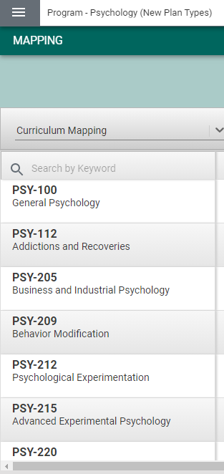

To the right each course is the Program Learning Outcomes (PLOs) for this program. These are the PLOs that have been entered for the Program Assessment Plan
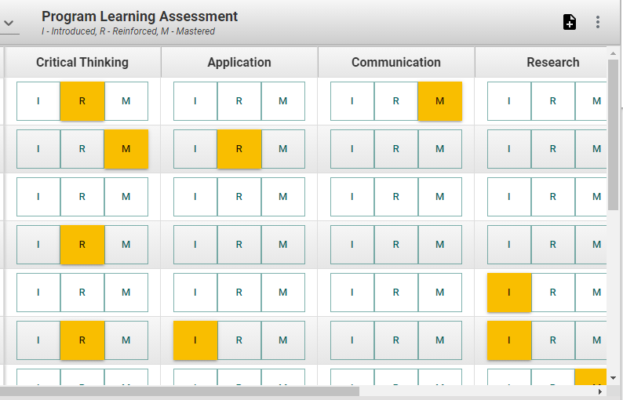

Indicators have been provided: I - Introduced, R - Reinforced, M - Mastered.
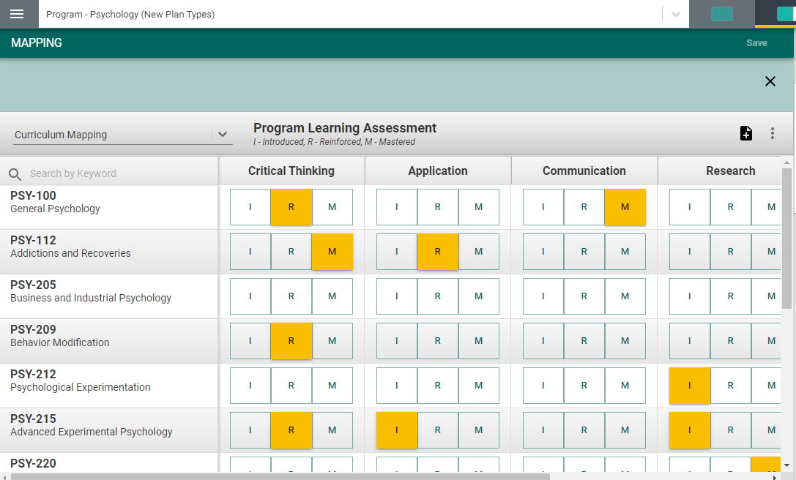
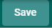
By clicking on the appropriate indicator under each PLO and aligned to the course(s) on the left, select where this PLO will be Introduced, Reinforced, of Mastered. Use the scroll bars at the bottom, and to the right, to move across the screen to reveal all courses and/or PLOs). If you would like to remove any mapping you have selected, click the selected indicator again to unselect. Once you have completed the mapping, the SAVE button, in the top right-hand corner, will illuminate and you will be able to save your mapping work.
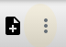
Another feature offered in the mapping screens is the option to add notes. Notice the icons to the right, just below the Save button.
By clicking on the ellipsis, the following options will appear. Add/Edit Note
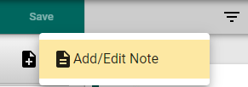

After clicking on the Add/Edit Note icon, the following dialog box will open.
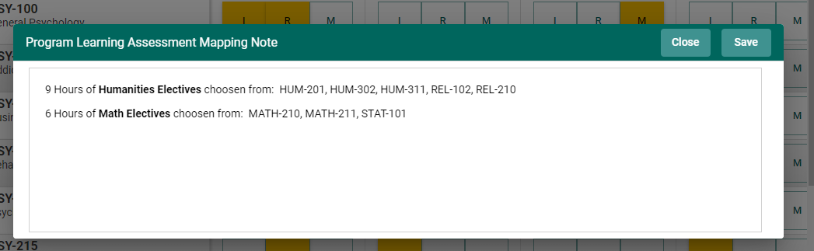
This is where you can add notes relevant to your mapping work. To add notes, Click within the dialog box. The dialog box now changes to a text box with options like that of a Word document. You will now be able to customize the font, add a table, include a picture or graphic, and/or link (URL) to an external document, and/or locate and include a document in your Document Library/Repository.
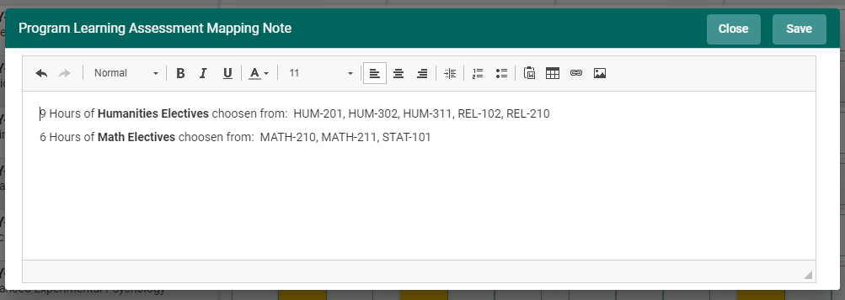
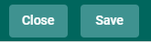
Once you have completed adding the Note, Click the SAVE button at the top of the card. Once you have saved the Note, and have completed adding notes, click Close.

Goals Mapping
For Goals Mapping you will select Goals from the drop-down.
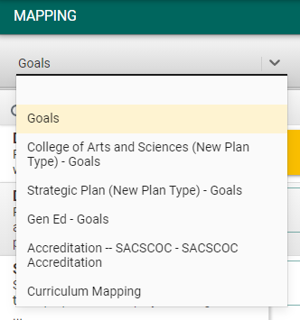

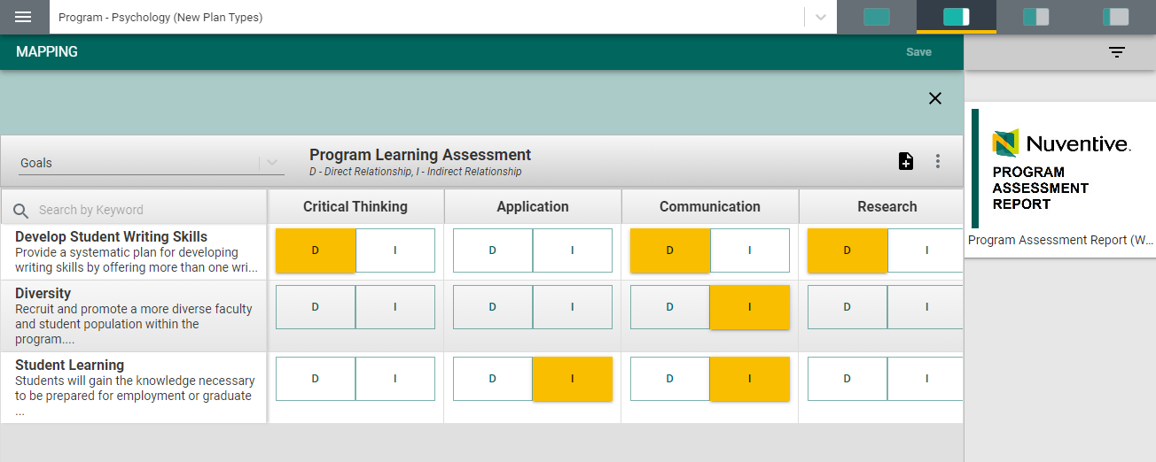
Next, notice that the goals are now listed in the left-hand column.
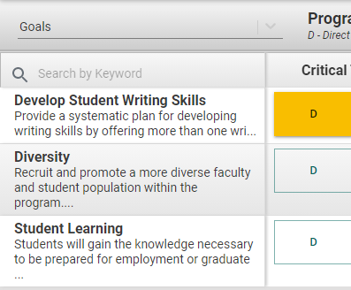
Also, notice that the Indicators have changed based on what your institutions has decided to use.
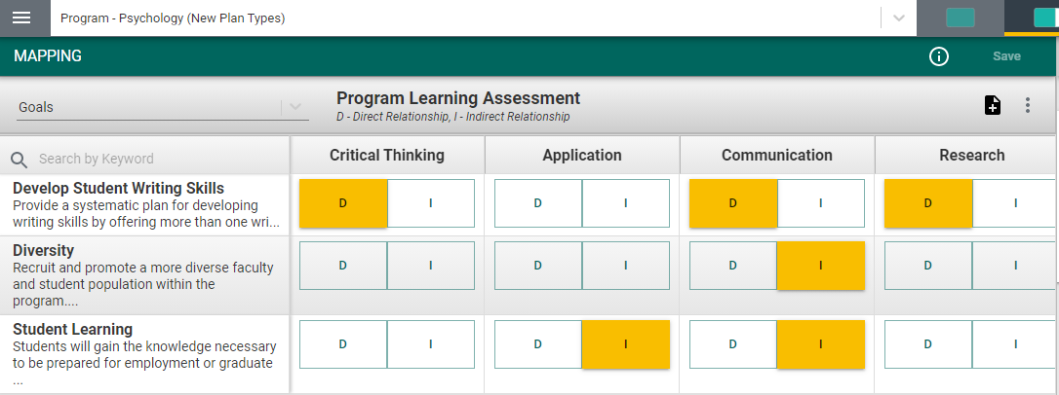
By clicking on the appropriate indicator under each PLO and aligned to the Goal(s) on the left, select where this PLO has a Direct or Indirect Relationship. Use the scroll bars at the bottom, and to the right, to move across the screen to reveal all Goals and/or PLOs). If you would like to remove any mapping you have selected, click the selected indicator again to unselect. Once you have completed the mapping, the SAVE button, in the top right-hand corner, will illuminate and you will be able to save your mapping work.
Another feature offered in the mapping screens is the option to add notes. Notice the icons to the right, just below the Save button.
By clicking on the ellipsis, the following options will appear. Add/Edit Note

After clicking on the Add/Edit Note icon, the following dialog box will open.
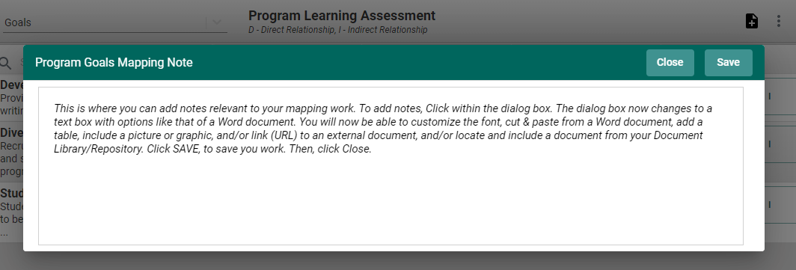
This is where you can add notes relevant to your mapping work. To add notes, Click within the dialog box. The dialog box now changes to a text box with options like that of a Word document. You will now be able to customize the font, add a table, include a picture or graphic, and/or link (URL) to an external document, and/or locate and include a document in your Document Library/Repository.
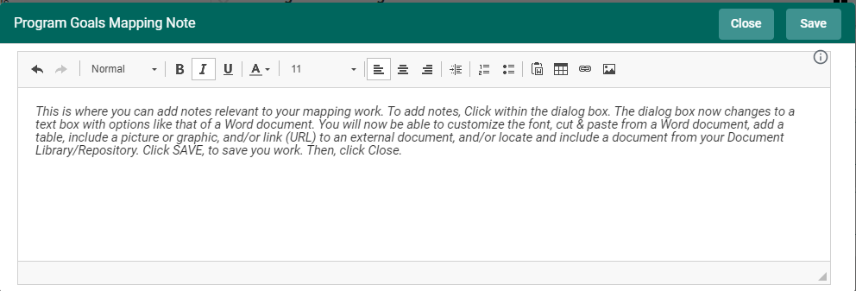
Once you have completed adding the Note, Click the SAVE button at the top of the card. Once you have saved the Note, and have completed adding notes, click Close.
You may now continue other mapping or, if you have completed all mapping for this session, return to the Main Menu by clicking on the Hamburger Menu

Reports

Document Library/Repository

DOCUMENT LIBRARY

The Document Library/Repository is where a variety of documents and files can be uploaded and stored for use within the Nuventive Improvement Platform. To find the Document Library/Repository, first click on the Hamburger Menu to reveal the Main Menu.

