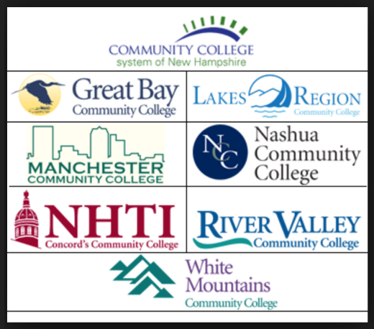
Letter of Intent to Plan for
New Degree Program,
New Certificate Program,
and Program Elimination

Please acknowledge that should this letter of intent to plan a new program or certificate program be approved, you will need to continue with the development and completion of the CCSNH Academic Program Proposal form. Your Vice President of Academic Affairs will then complete the process with the system wide VPAA group, system leadership team, and the board of trustees.
You will need to submit a letter of intent to the VPAA if you are planning a curriculum change that involves one of the following:
- New Degree Program
- New Certificate Program
- Program Elimination
Your letter should provide a brief overview of each of the following topics. If your intent to plan is approved, you will be asked to provide additional explanation and supporting materials on the CCSNH Academic Program Proposal Form.
Rationale for New Program
Needs Assessment (In your response, please address each of the topics below and provide supporting data as applicable.)
- Career Opportunities (Burning Glass, DOL)
- Connection to College Strategic Plan
- Fit within CCSNH
- Need within local community; region
- Describe similar programs offered at other CCSNH colleges
- Describe efforts made to collaborate with similar programs offered at other CCSNH colleges
- Describe support from business and industry partners/advisory boards

Impact on Existing Programs
- Internally
- System Wide

Pathways (Describe existing and potential pathways for each area below)
Local high schools (Running Start/Early College)
CTE Partnerships (Secondary)
Four-year Colleges/Universities
Business and Industry/Apprenticeships
Resources and Financial Costs, Sustainability (Briefly describe the impact on each area below)
Faculty
Facilities
Library
Technology
Equipment/Materials/Licensing/OER
Special Apparatus
Communications Plan with Marketing/Admissions
Estimate of Total Costs/Revenue
Fees
Enrollment (Projected)/Size

Approval to Plan:

VPAA_____________________________________________
Signature

College President____________________________________
Signature

Meeting Dates for Recommendation to Plan:
CCSNH VPAA Group _____/______/________
Feedback for Department Chair or Program Coordinator (if applicable):

System Leadership Team Informed of Intent to Plan _____/______/________

