Accepting or Declining Loans in SIS
- ONLY If you are going to accept a loan, confirm the following before proceeding to step 2
  - Review the updated loan guidance for 2026-2027 on CCSNH.edu
  - Confirm that you are enrolled in 6 or more credits for the semester (check with your advisor if you're unsure)
  - Confirm you have completed the Loan Entrance Counseling on StudentAid.gov
  - Confirm you have completed the Master Promissory Note (MPN) on StudentAid.gov
- ONLY if you need to take loans for the summer semester, submit the Summer Loan Request then stop. We need to repackage your loans before you can accept them. Once you receive the "revised aid offer" email you will be able to continue with these steps.
- Login to https://portal.ccsnh.edu and click on SIS9 – Student > "Financial Aid"
  - 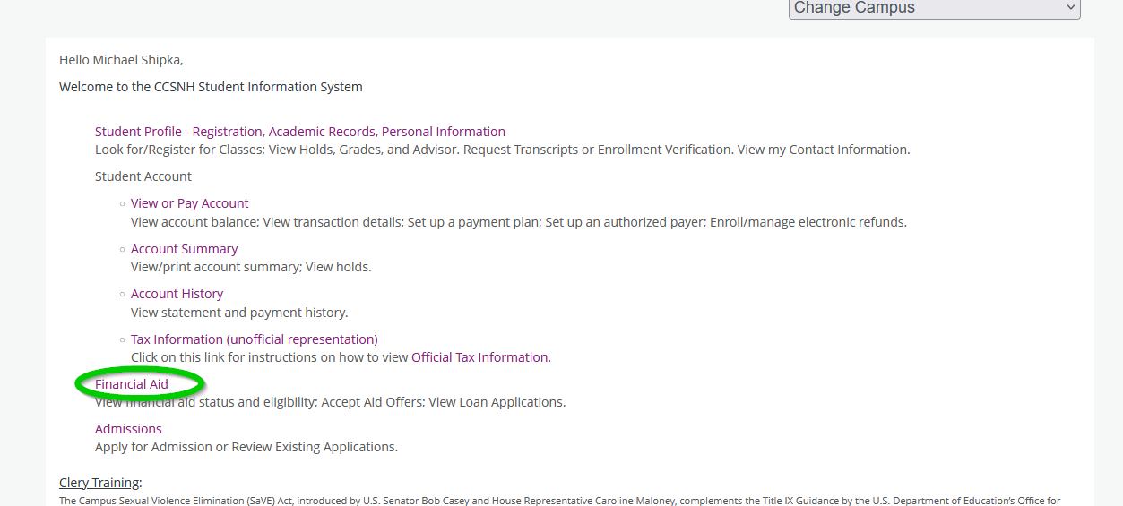
- Click the "Aid Year" dropdown in the top right corner, and select the year you want to accept loans for (to see which aid year applies to which semester, refer to the “Which FAFSA Do I File” section of the Financial Aid page)
  - 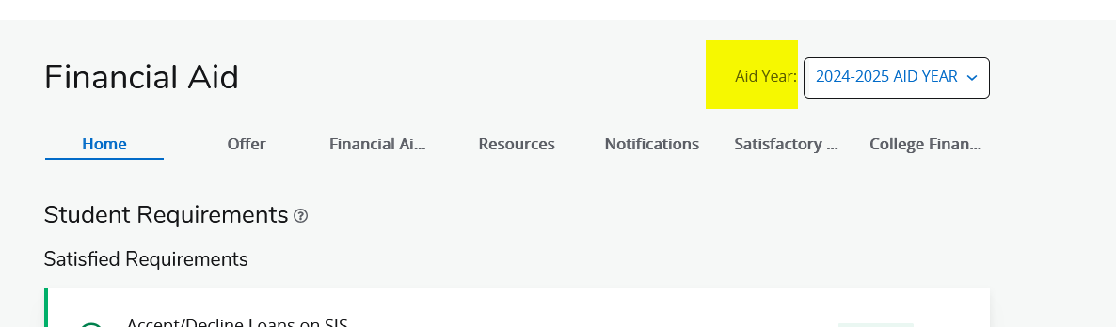
- On the "Home" tab, if you see a red box with "Questions from the financial aid office", click "View Questions" and provide your answer. The most common questions here are regarding whether or not you want to use your financial aid to buy books from the NCC bookstore (known as the "Book Advance"). Accept all three of these.
  - 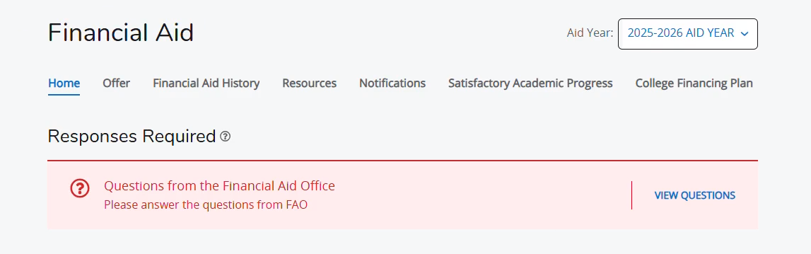
- Further down on the "Home" tab, you will see a list of "Student Requirements". Ensure all requirements are green and/or "Satisfied"
  - 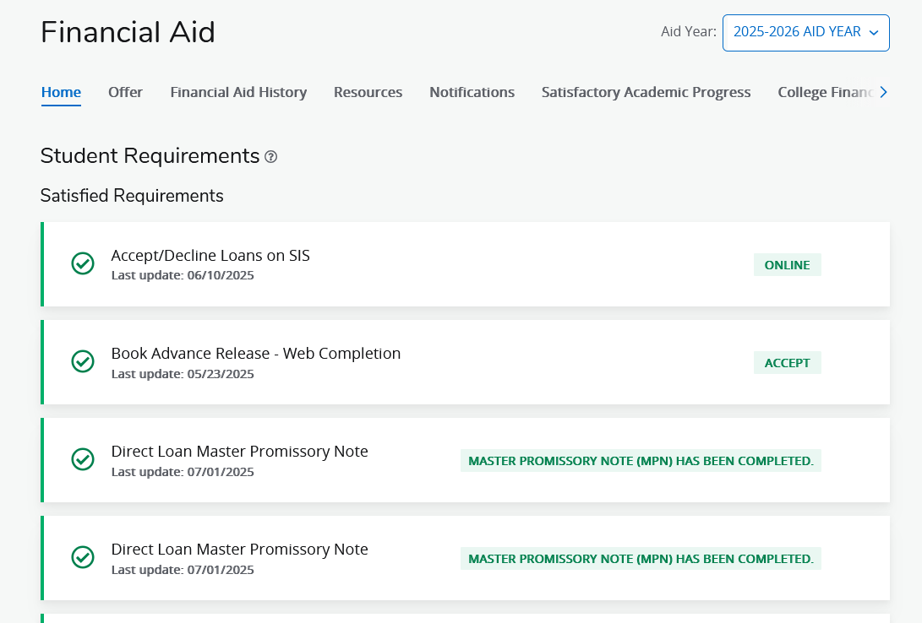
- Click on the "Offer" tab
  - 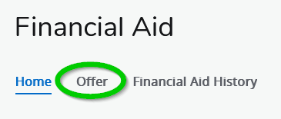
- Scroll down to the "Loans" section and select whether or not you'd like to accept the loans.
  - If accepting a partial amount, please bear in mind that the amount you enter will be split across all of your semesters you are attending for the remainder of the school year.
- Click "Submit"
  - 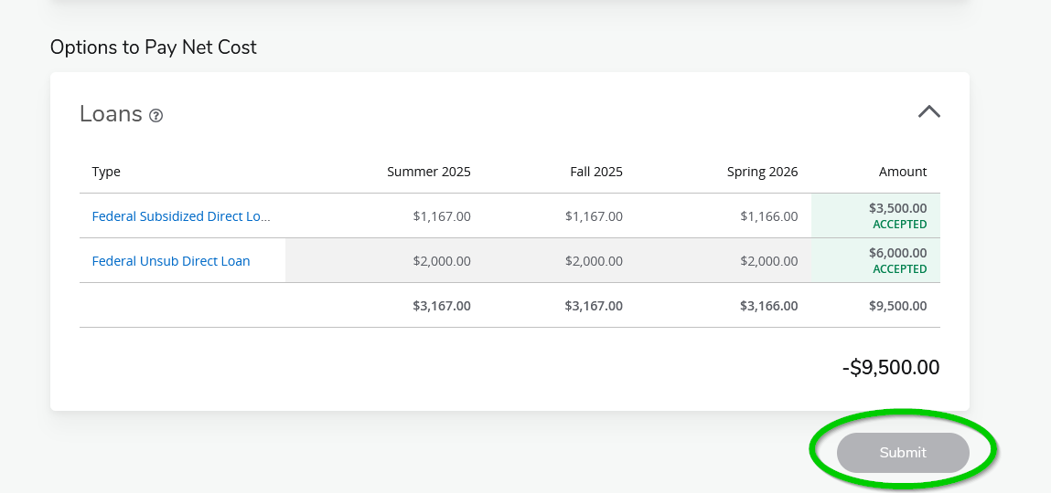
- Email NCCFinAid@ccsnh.edu to let us know you’ve completed these steps

